

SCHOOL OF ARCHITECTURE, COMPUTING & ENGINEERING
Department of Computer Science and Digital Technologies – CDT
CN7021 – Advanced Software Engineering

Hospital Management System
Group: GP 5.E
Students Name & ID:
Het Ramanbhai PATEL - U2794451
Soham Nareshbhai PATEL - U2799710
Anmol PUNDIR - U2740118
Shisir REGMI – U2780253

Tutor: Abdulrazaq Abba
Module Leader: Dr Hisham AbouGrad

Month Year

Table of Contents

1. Introduction 4
1.1 Purpose 4
1.2 Document Conventions 4
1.3 Intended Audience and Reading Suggestions 4
1.4 Product Scope 4
1.5 Requirements Reference Documents 4
2. Overall Description 5
2.1 Software Architecture and Methodology 5
2.2 Product Functions and Use Cases 6
2.3 User and Stakeholders 9
2.4 Operating Environment 9
2.5 System Design and Implementation Constraints 9
2.5.1 System Design 9
2.5.2 Implementation and System Development 11
2.6 User Documentation 13
2.7 Assumptions and Dependencies 13
3. External Interface Requirements 14
3.1 User Interfaces 14
3.2 Hardware Interfaces 14
3.3 Software Interfaces 14
3.4 Communications Interfaces 14
4. System Requirements 15
4.1 Requirement F1 15
4.2 Requirement F2 (and so on) 15
5. User Stories and Scenarios 16
6. Nonfunctional Requirements 17
6.1 Performance Requirements 17
6.2 Safety Requirements 17
6.3 Security Requirements 17
6.4 Software Quality Attributes 17
6.5 Other External Requirements 18
6.6 Business Rules 18
7. Software Testing and Test Plan 19
7.1 Test Suite T1 19
7.2 Test NF Requirement NF1 19
8. Project Management 20
9. References 21
10. Appendices 24
10.1 Appendix A: Contributions Table 24
10.2 Appendix B: Agreement of Participation 24
10.3 Appendix C: Glossary 24
10.4 Appendix D: Analysis and Design Models 24
10.5 Appendix E: To Do List 25
10.6 Appendix F: Source Code 25
10.7 Appendix G: System Screenshots 25

List of Figures
Figure 1: Software Architecture 5
Figure 2: Use Case for Doctor 6
Figure 3: Use Case for Patient 7
Figure 4: Use Case for Admin 8
Figure 5: Activity Diagram for Doctor 10
Figure 6: Activity Diagram for Patient 11
Figure 7: Login Page of Doctor 12
Figure 8: OTP Verification from patient side 12
Figure 9: Patient side login 13
Figure 10: Gantt chart 20

List of Tables
Table 1: Contributions Table 24
Table 2: Student Details 24
Table 3: Glossary 24
Table 4: To Do List 25

Introduction

Purpose
This data focuses on estimating the effort and cost required to develop a healthcare-related software program solution using the COCOMO II (Constructive Cost Model) (Putri, Siahaan and Fatichah, 2024). The selected methodology enables a based approach to expect software project consequences using thinking about various experience attributes and constraints. The report also explores the application of automated tools for cost estimation, permitting a more accurate and effective evaluation. By using each manual and automatic technique, the report provides a comprehensive understanding of the attempt required to execute the project efficiently.

Document Conventions
The estimations adhere to the same old COCOMO II formulation, which is well-identified in software engineering for venture evaluation. All calculations are supported by the provided project metrics and the additional resources. Transparency is ensured through the distinct presentation of the estimation technique, with all key steps documented.

Intended Audience and Reading Suggestions
The primary audience for this report consists of software developers, project managers, academic evaluators, and different stakeholders apprehensive about project planning and execution (Tinoco et al., 2023). For a logical study importance, it's recommended initially the technique phase, which outlines the estimation manner, observed through the effects and discussion sections for insights into the derived outcomes.

Product Scope
The report is designed to streamline healthcare strategies by estimating the cost and attempting to increase one of the following software program solutions:
Crowdsourced Hospital Reviews & Feedback: A platform for real-time patient comments on medical institution services.
Authentication with Email OTP Verification: Ensures secure access to the device and prevents fraud or scams.
Doctor Management through Admin: Admin can upload and alter physician info to hold correct and up-to-date data.
Patient Doctor Selection: Patients can select doctors themselves based totally on availability and preferences.

Requirements Reference Documents
The CN7021 Moodle page for CKJM tools.
Online resources and documentation for COCOMO II estimation tools.

Overall Description

Software Architecture and Methodology
The selected healthcare-related software project is designed to address specific needs within the healthcare surroundings, including streamlining feedback mechanisms, imparting personalized care, or optimizing affected individual discharge workflows (Lin, 2024). The high-level architecture is modular, permitting impartial additives to interact seamlessly even while retaining scalability and reliability.

The architecture adopts a three-tier structure:
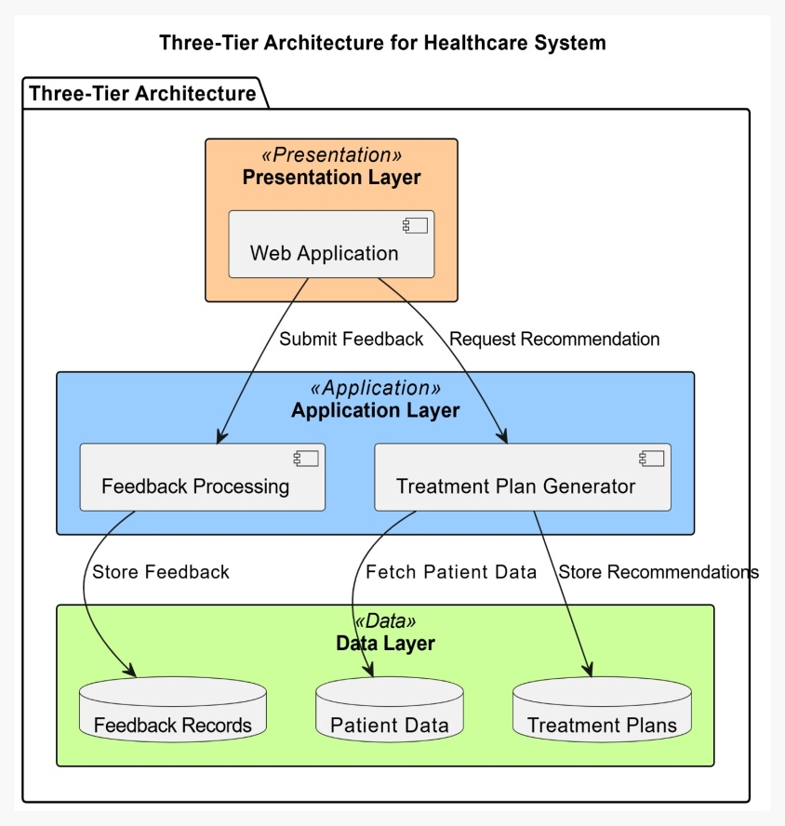
Figure 1: Software Architecture
Source: Self-created

Presentation Layer: This includes the user interface components, which include cellular and internet programs, permitting customers to engage with the device. For example, sufferers can rate offerings or access customized recommendations.
Application Layer: Responsible for business logic, this layer handles workflows which include reading affected person comments, generating treatment plans, or coordinating aftercare methods.
Data Layer: This consists of databases and storage solutions for securely coping with patient data, feedback data, and other important records.
For effort and cost estimation, the COCOMO II (Constructive Cost Model) methodology is carried out. This version evaluates attempt as a characteristic of project length, complexity, and diverse environmental elements, the usage of parameters which include KLOC (thousand lines of code) and Effort Adjustment Factor (EAF) (Mrvar, 2023). It helps task classifications like natural, semi-detached, and embedded, aligning with the numerous natures of healthcare structures.

Product Functions and Use Cases
Each selected software program machine is designed with a hard and fast of core functionalities and use cases tailored to healthcare necessities:
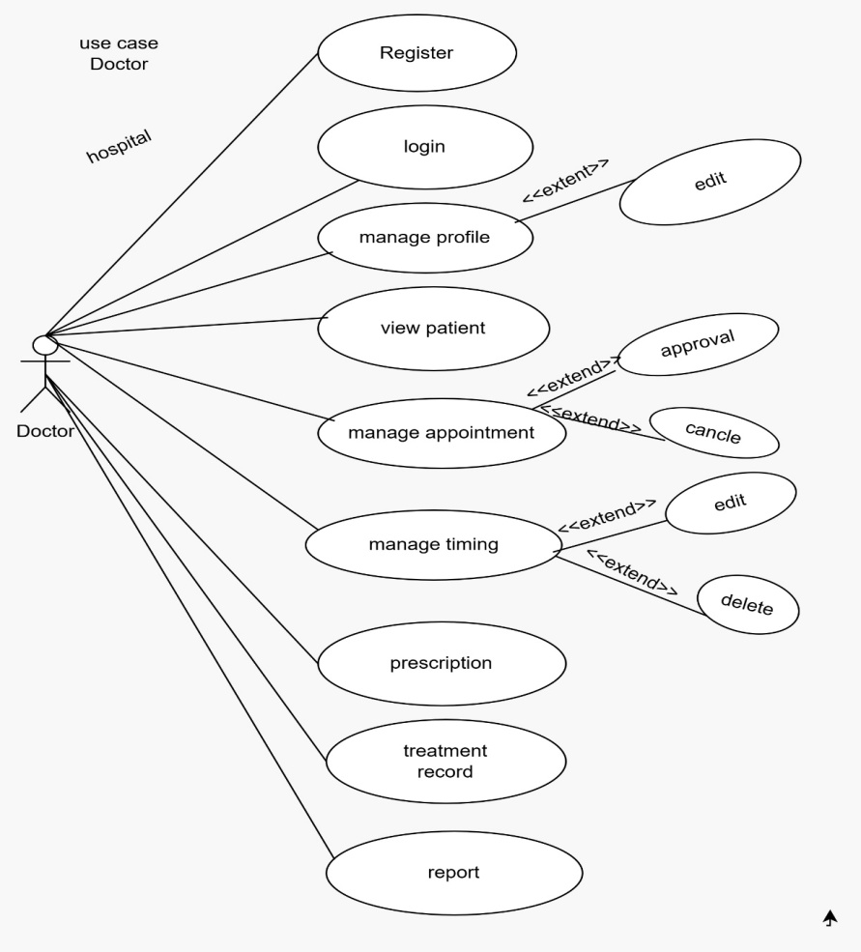
Figure 2: Use Case for Doctor
Source: Self-created
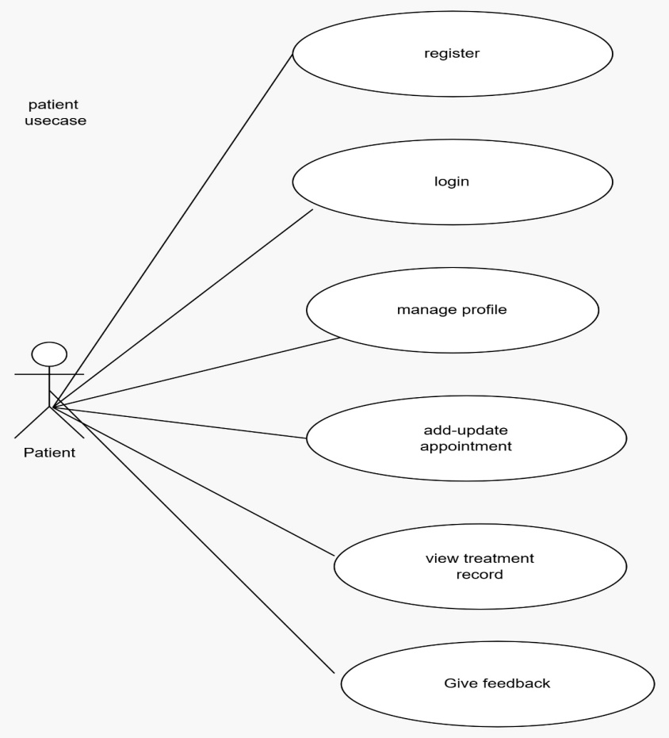
Figure 3: Use Case for Patient
Source: Self-created

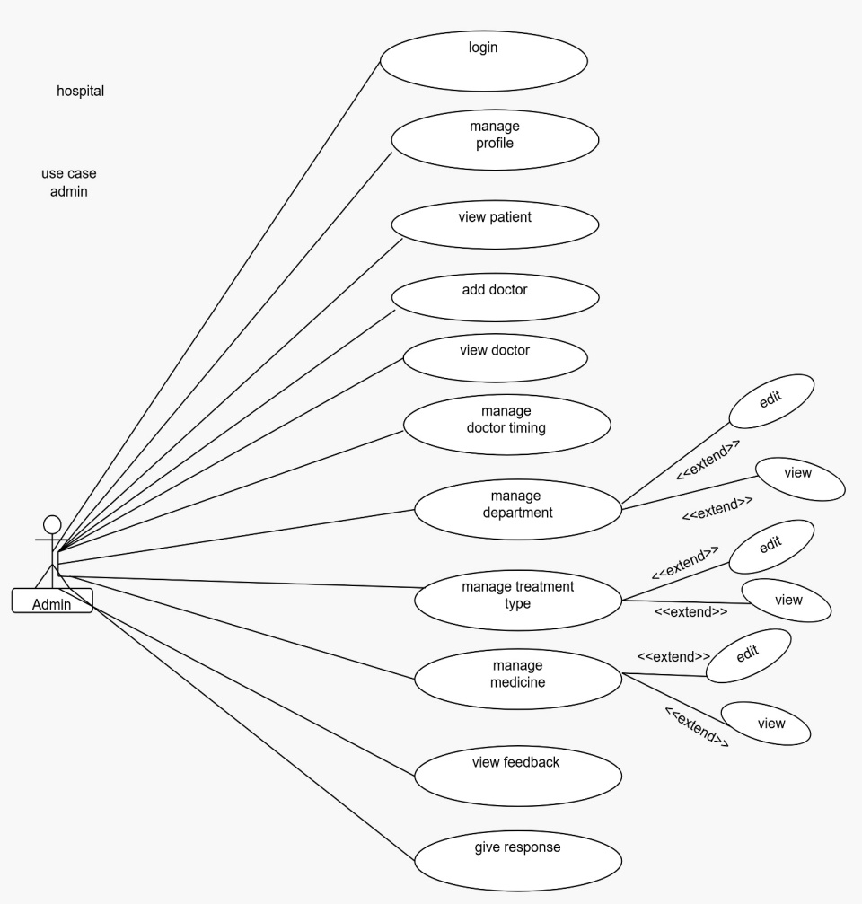
Figure 4: Use Case for Admin
Source: Self-created

Crowdsourced Hospital Reviews & Feedback:
Functionality: Allows sufferers to rate healthcare offerings and offer feedback in real-time. Includes authentication with Email OTP verification to prevent fraud and ensure legitimate users access the system.
Use Case: An affected person submits an overview of health facility cleanliness, which the system shops in a centralized database for evaluation through administrators.

Doctor Management using Admin:
Functionality: Enables the admin to add and modify health practitioner details, ensuring accurate and updated data (Ericsson Duffy, 2020).
Use Case: The admin updates a medical doctor's profile, which displays inside the device for patients to view.

Patient Doctor Selection:
Functionality: Allows sufferers to choose doctors themselves primarily based on their preferences and available information.
Use Case: A patient logs into the system, browses through the listing of doctors, and selects a medical doctor for consultation.

User and Stakeholders
The primary users and stakeholders of the system consist of:
Patients: The end users who can offer feedback on health centre services and pick out medical doctors for their consultations (Bhati, Deogade and Kanyal, 2023).
Doctors: Key users who provide healthcare offerings and whose profiles are controlled and updated using the admin.
Admin: Responsible for handling the system, consisting of physician information, user feedback, and authentication strategies to ensure machine integrity.

Operating Environment
The system is designed to function within the following environments:
Web Application: The system is available through a web-based totally utility, which allows patients, doctors, and directors to engage with its functions seamlessly (Joshua et al., 2023).
Local Server/Host: The system might be hosted on a neighbourhood server to make certain stable, managed access and efficient performance within the healthcare surroundings.

System Design and Implementation Constraints

System Design
The system design is modular to make certain flexibility, scalability, and safety, with seamless integration into existing hospital management structures like EHR. Key additives consist of:

User Interface (UI): Responsive web application for easy access to healthcare providers and patients.
Backend Services: Robust services for handling affected person records, comments, and treatment recommendations.
Data Storage: A stable, centralized database for storing crucial statistics with excessive availability.
Security: Compliance with HIPAA and GDPR ensures encryption and access to manipulate patient information (Lee, Chang and Su, 2023).
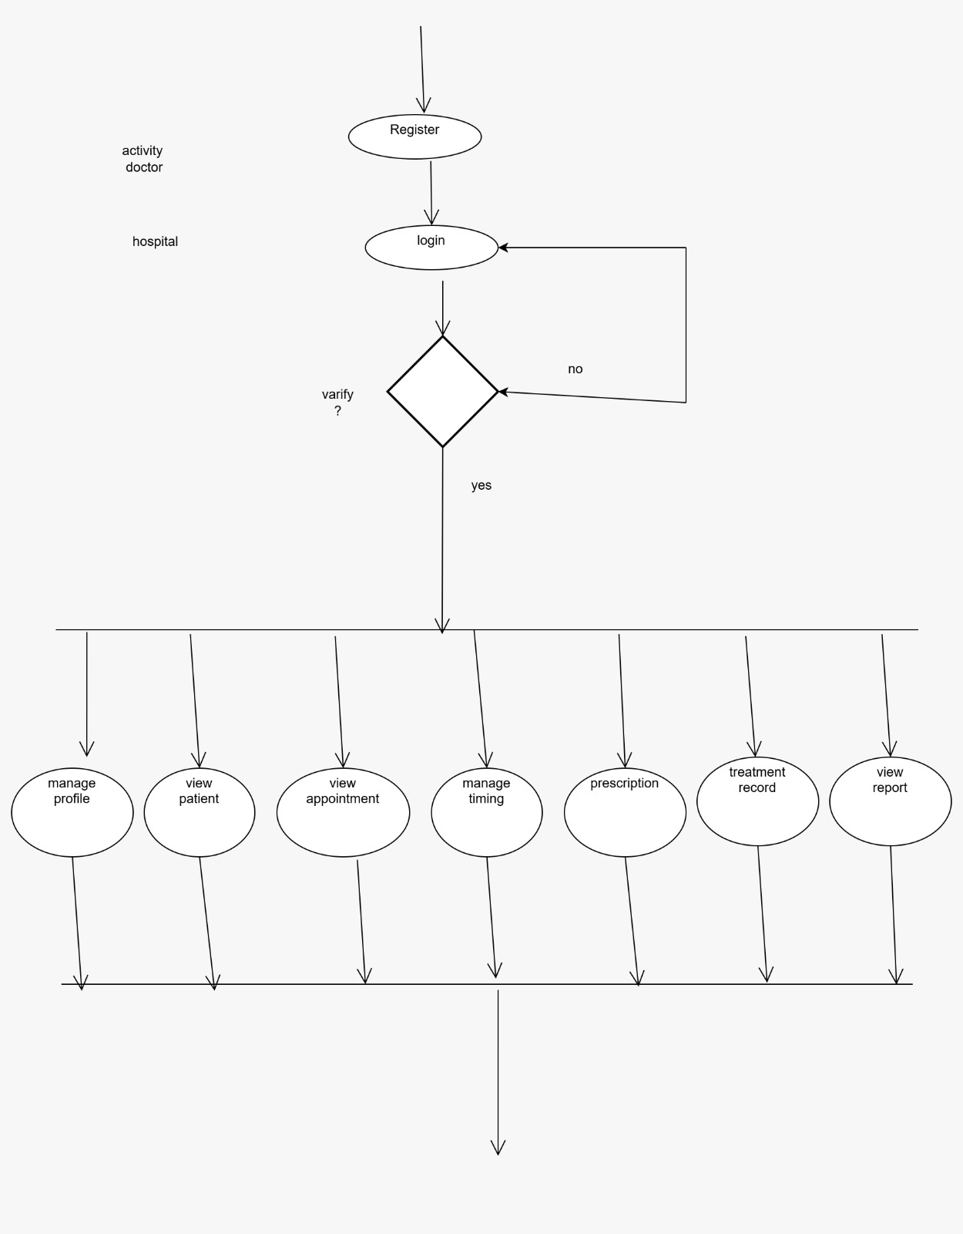
Figure 5: Activity Diagram for Doctor
Source: Self-created
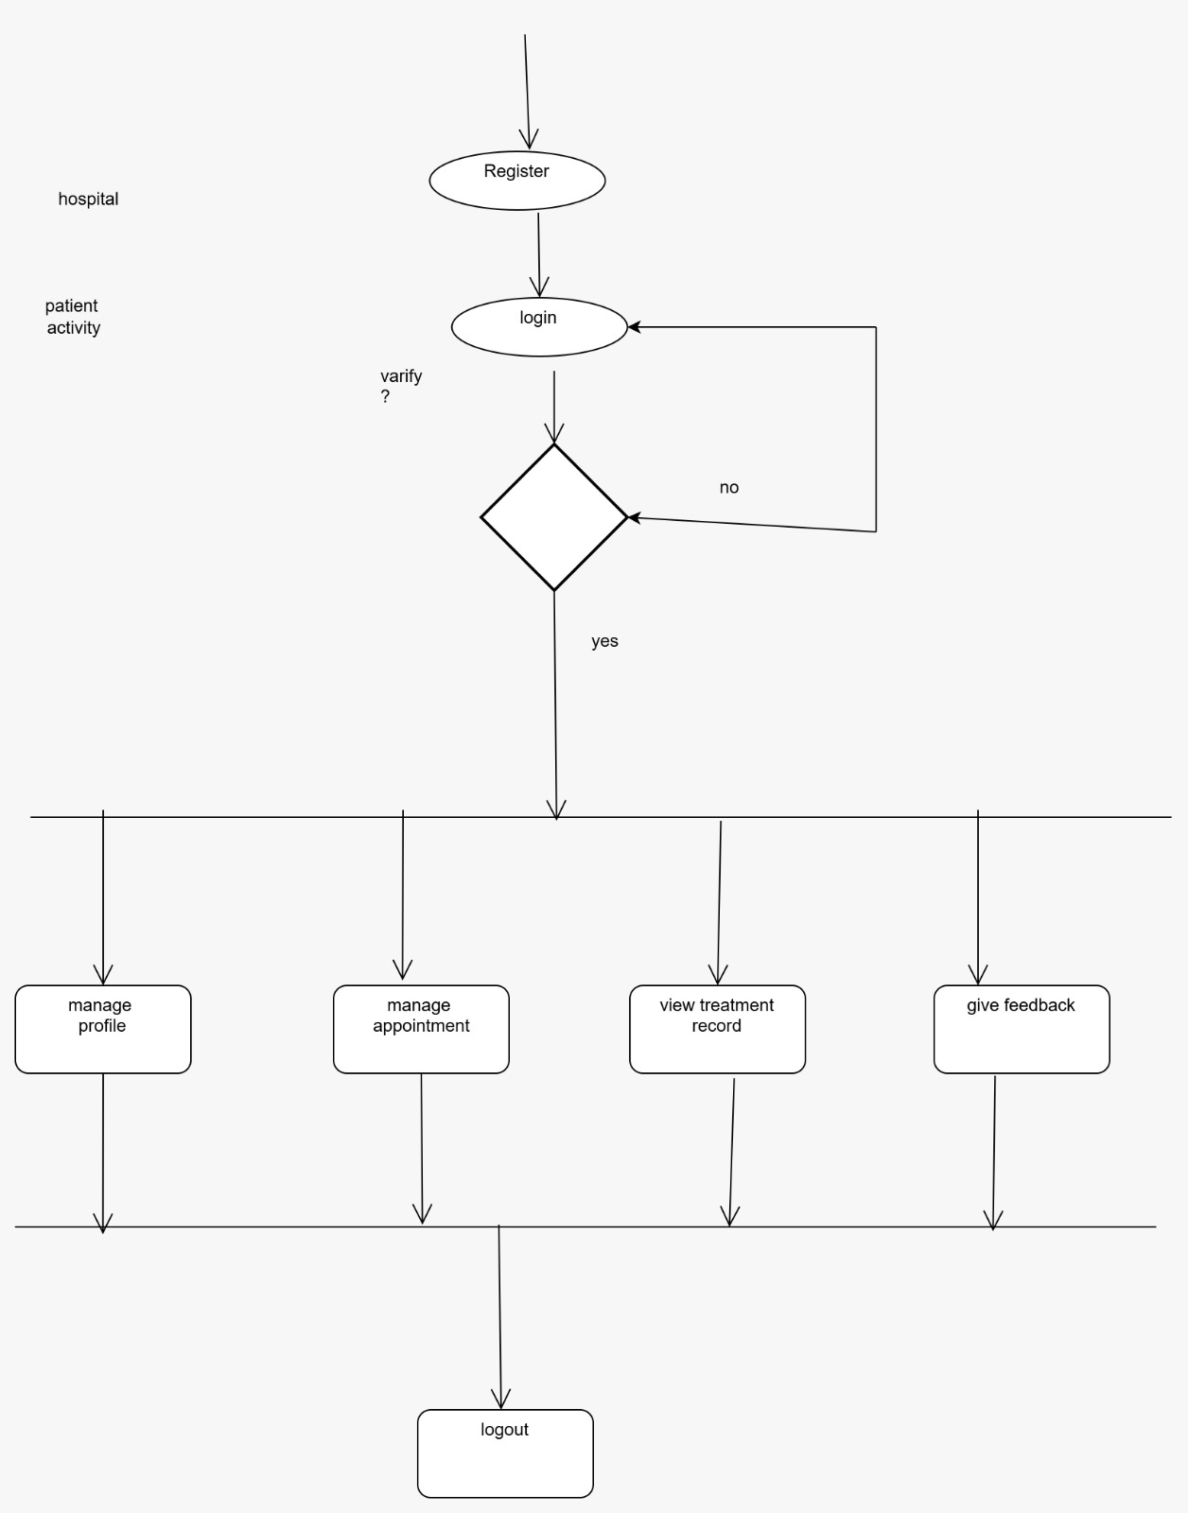
Figure 6: Activity Diagram for Patient
Source: Self-created

Implementation and System Development
The project will undertake agile practices for iterative releases and non-stop comments. Key additives:

Technology Stack: PHP for the backend, HTML/CSS for the front end, and AWS for website hosting.
Development Tools: Git, Jenkins, and Docker for efficient development (Kavya and Smitha , 2022).
Testing: Automated testing with XMAP.
Deployment: Staged deployment with everyday updates based on comments.

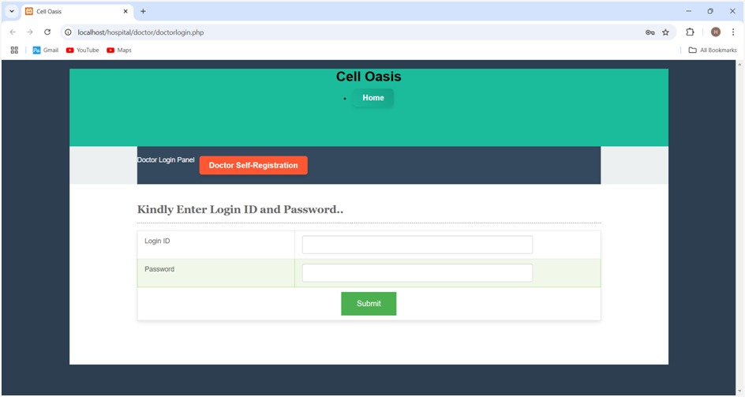
Figure 7: Login Page of Doctor
Source: Self-created
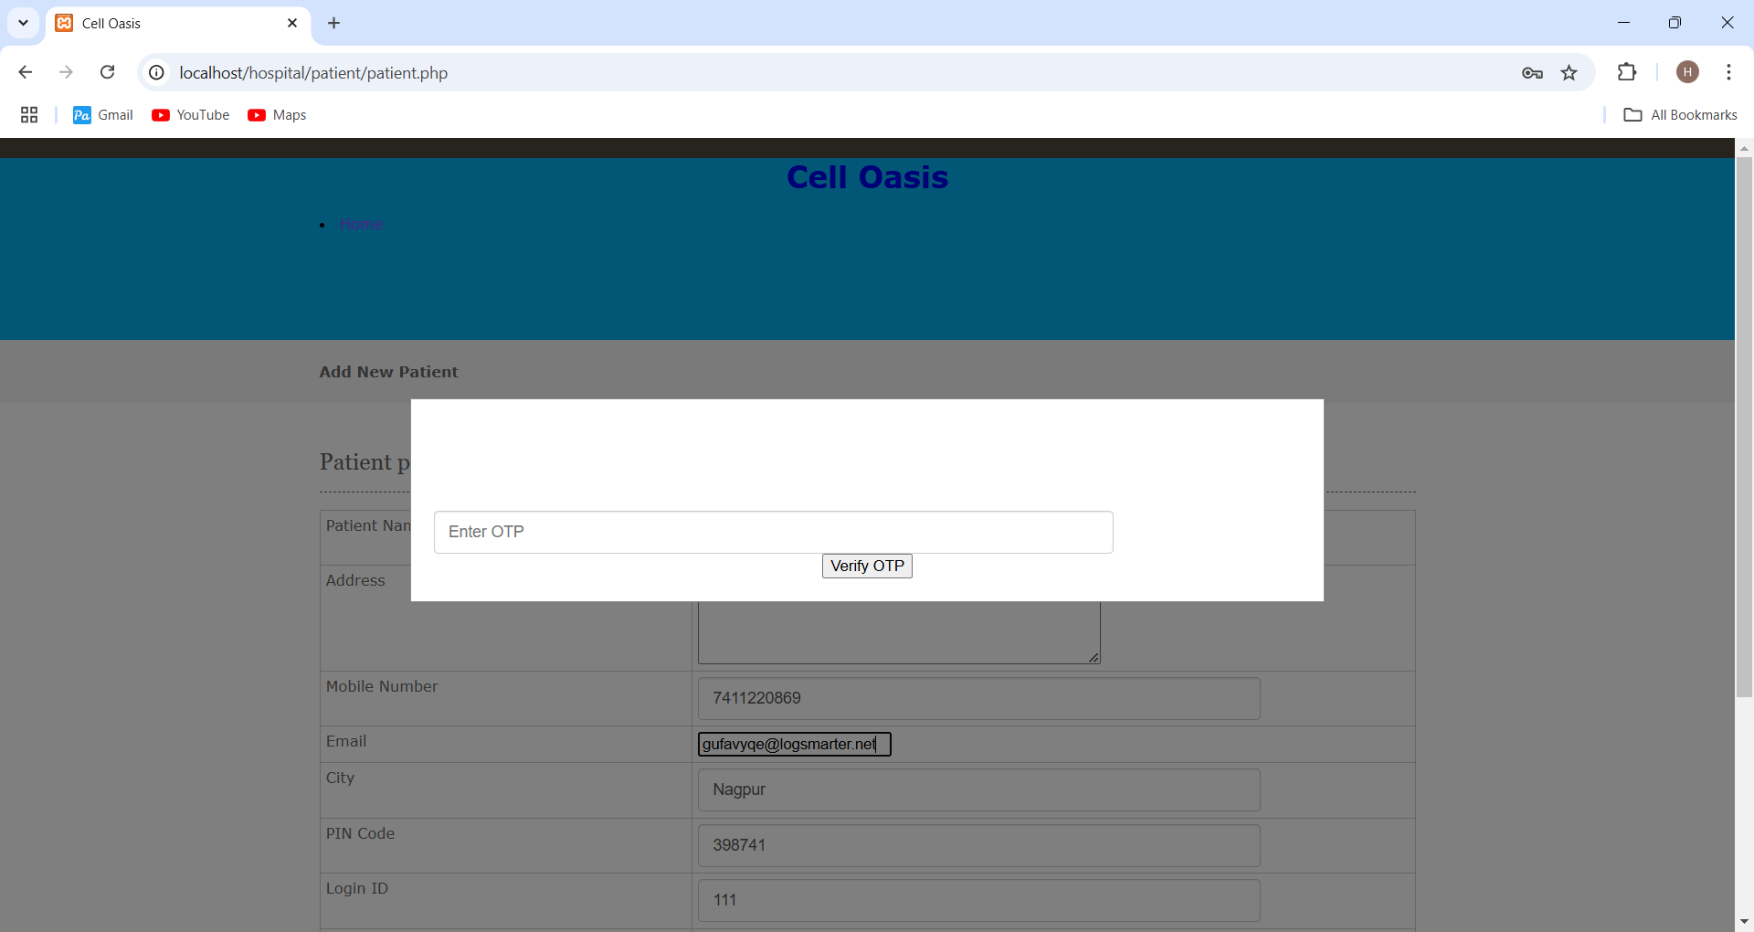
Figure 8: OTP Verification from patient side
Source: Self-created
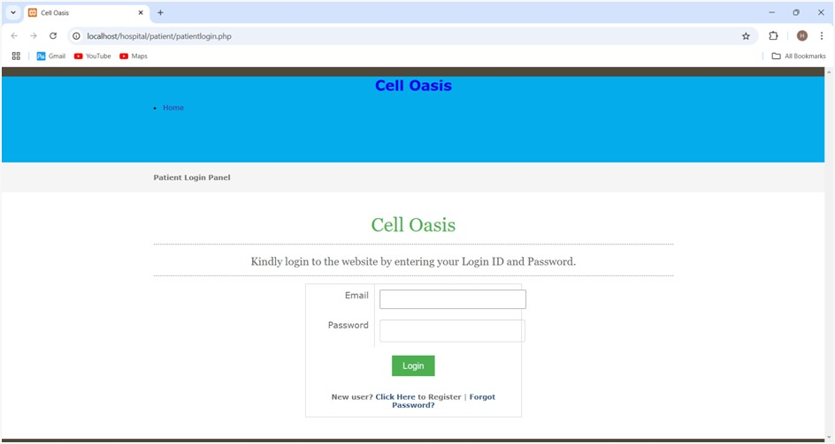
Figure 9: Patient side login
Source: Self-created

User Documentation
User documentation will include:

User Manuals: Step-by-step guides for stop-customers (providers and healthcare companies).
Online Help: Context-sensitive help is included within the software.
Tutorials: Interactive tutorials for new customers to quickly discover ways to use the system.
These might be added in PDF and HTML codecs, adhering to installed user documentation standards.

Assumptions and Dependencies
Assumptions: It is assumed that the device might be accessed on the right device, together with a PC or Laptop, and that users can open the website on mobile devices if vital (Pedral Sampaio, Aguiar Costa and Flores-Colen, 2022).
Dependencies: The project is based on pre-constructed templates for device capability instead of AI and ML. Additionally, an external API is used for OTP verification to ensure steady authentication.

External Interface Requirements

User Interfaces
The system's user interface (UI) design is essential for healthcare experts and patients (Larasati, De Liddo and Motta, 2021). It may have responsive web and mobile applications, making sure a seamless experience throughout devices. The UI will streamline workflow, offer real-time records updates, and provide clear get entry to affected individual records. Dashboard-style interfaces will help directors screen affected person feedback, track remedy development, and control aftercare schedules.
The interface can be designed for sufferers with restrained technical enjoy, ensuring accessibility and simplicity.

Hardware Interfaces
The system will perform on the following hardware:
PC/Laptop: The system might be reachable through PCs and laptops, making sure healthcare professionals and administrators can effectively manipulate responsibilities which include doctor management, affected person comments, and appointment handling (Haleem et al., 2021).

Software Interfaces
The system will need to interact seamlessly with current health facility control systems, which include Electronic Health Records (EHR) to offer real-time data updates and processing. Key software interfaces include:
EHR Integration: The system will synchronize with EHRs to drag patient data, treatment plans, and clinical histories for accurate hints (Heggelund, 2023).

Communications Interfaces
The system will depend upon diverse communication protocols to ensure stable, green statistics transmission among users, devices, and the backend. Key communication protocols and community dependencies encompass:
HTTP/HTTPS: Standard internet protocols may be used for communication among the frontend interfaces (cellular/net apps) and the backend server (Wendroth and Jaeger, 2022). All communication will be encrypted using TLS/SSL to steady affected person information.
RESTful APIs: The tools will use REST APIs to communicate with medical institution control systems and third party services. These APIs will permit the exchange of dependent statistics (e.g., patient facts, treatment plans) in JSON format.
Real-Time Updates: For real-time conversation (e.g., live feedback collection), WebSockets can be utilized to permit regular records flow between affected person gadgets and the backend device.

System Requirements

Requirement F1
The system is designed to offer key functionalities that meet the necessities of healthcare professionals and sufferers. These key features include:
Real-time Feedback Collection: Patients can publish remarks on their healthcare satisfaction through a user-friendly interface (Lim et al., 2022). The system will provide instantaneous comment processing, allowing directors to view responses and take appropriate movements. Feedback classes may additionally encompass medical institution cleanliness, the body of workers' professionalism, and patient experience.
Authentication with OTP Verification: To ensure steady access and prevent unauthorized customers, the system will use an outside API for OTP (One-Time Password) verification for the duration of user authentication (Faruque, 2024). This will help hold the integrity of the platform and stop fraudulent activities.

Requirement F2 (and so on)
Performance Requirements:
The system ought to deal with high traffic volumes, particularly for the duration of peak hours, to make certain that patient remarks are processed at once (Varnosfaderani and Forouzanfar, 2024). The system should guide at the least 500 concurrent customers and provide actual-time processing of feedback submissions.
Response times for affected person queries and remarks show ought to be underneath 2 seconds to make certain a unbroken person experience.

Security Requirements:
Data Encryption: All sensitive information, such as patient facts and feedback, ought to be encrypted the usage of TLS/SSL protocols at some stage in transmission.
Access Control: The system must put into effect role-based access controls (RBAC) to restriction get access to sensitive records based on consumer roles (e.g., administrators, healthcare providers, patient) (Guesmi, 2023).
Authentication: Two-factor authentication (2FA) will be required for gaining access to sensitive healthcare information and gadget functions.

Scalability:
The system should be scalable to house developing affected person bases and data as hospitals make bigger. It needs to be designed to without difficulty scale horizontally on cloud platforms like AWS or Azure.

Usability:
The system should have a patient-satisfaction interface with minimal getting to know curve for patients, healthcare vendors, and directors.
Accessibility features, such as voice commands for patients and high-comparison modes, need to be covered to cater to customers with disabilities.

User Stories and Scenarios
User Story 1: Patient Feedback Submission
As a patient, I want to post remarks about my health center experience through an easy interface, so I can percentage my reviews about the quality of care I received.
Scenario:
The affected person accesses the internet application.
They choose a category (e.g., cleanliness, personnel professionalism) and offer a score or written remarks.
The system confirms submission and shops the data in a centralized database for real-time evaluation through health facility directors.

User Story 2: Secure User Authentication
As a user, I want to authenticate myself with the use of OTP verification during login, so I can securely access the system without unauthorized access.
Scenario:
The consumer enters their email or phone variety in the course of login.
The system sends a one-time password (OTP) to the provided e-mail/telephone quantity.
The person inputs the OTP to affirm their identity, and the system presents access to the platform.

User Story 3: Patient Doctor Selection
As a patient, I need to pick a selected doctor for my appointment, so I can talk over with a medical doctor of my preference.
Scenario:
The patient logs into the system.
They navigate to the listing of available medical doctors.
The patient selects a medical doctor based on their details (e.g., specialization, availability).
The system schedules an appointment with the selected physician and confirms the reservation.

Nonfunctional Requirements

Performance Requirements
The system needs to meet the following performance standards:

Response Time:
Patient remarks submissions should system and store data in under 2 seconds to ensure smooth patient satisfaction in high-traffic areas like ready rooms (Harris, 2020).
Real-time updates for patient feedback and appointments should be meditated right away across all interfaces.

Scalability:
The system must support 500 concurrent users without overall performance degradation.
The system needs to permit horizontal scaling to manipulate the growing person base and facts.
These necessities ensure a responsive, efficient system which can scale as expected.

Safety Requirements
The device should ensure the protection of each customer and information:

Data Integrity:
Implement normal data backups and real-time synchronization to prevent loss or corruption of affected person statistics throughout system failures (Yusof, Ping and Isa, 2023).

Patient Safety:
Safety-critical alerts for overlooked medications or compliance with follow-ups are to be communicated certainly.

Compliance:
The system must follow HIPAA and GDPR policies for stable management of patient data.

Security Requirements
Robust security measures are critical for protecting sensitive healthcare data:

Data Protection: Sensitive data have to be encrypted with the usage of AES-256 encryption for the duration of both transmission (TLS/SSL) and storage (Yevseiev et al., 2023).
Authentication: The system would require two-factor authentication (2FA) for healthcare professionals and fundamental authentication or biometric reputation for patients.
Access Control: Role-based access control (RBAC) will restrict entry to sensitive data, making sure the most effective authorized users can view or modify it.
Regulatory Compliance: The system should observe GDPR, HIPAA, and different applicable privacy standards.

Software Quality Attributes
The system should demonstrate the following attributes:

Usability: The personal interface ought to be intuitive, with a minimum learning curve for each patient and healthcare expert.
Reliability: The system needs to have 99.9% uptime, ensuring non-stop availability for crucial offerings.
Maintainability: The device ought to be modular and well-documented to guide future updates and scaling.
Interoperability: The system needs to seamlessly combine with present EHR systems and other hospital management software programs.

Other External Requirements
Database Requirements: Use a relational database management system (RDBMS) which includes PostgreSQL or MySQL for stable data storage (Shumilov, 2024).
Legal Requirements: The device should adhere to applicable records safety laws and affected person privacy rules within the jurisdictions wherein it operates.

Business Rules
User Roles: Healthcare directors can get access to analytics and comments reviews, while sufferers can submit feedback and look at their treatment recommendations (De Croon et al., 2021).
Data Submission: Patient remarks ought to be anonymous, however, healthcare carriers can track comments related to unique sufferers.
These guidelines ensure the system aligns with operational and regulatory requirements.

Software Testing and Test Plan
The testing method for this project follows a multi-layered method to make sure the machine meets both functional and non-functional requirements. This consists of unit testing for individual additives, acceptance trying out for end-to-end functionality, and overall performance testing to validate scalability and reaction times.

Test Suite T1
Functional Requirements (F1): Real-time feedback submission system.
Nonfunctional Requirements (NF1): Performance requirements related to response time and scalability.
    - Unit Tests
Unit Tests:
File: feedback.php
Method: testSubmitFeedback()
Purpose: Test the submission functionality of patient feedback to ensure that data is correctly recorded and processed.
File: send_otp.php
Method: sendotp()
Purpose: Test the OTP verification process to ensure that one-time passwords are generated, sent, and validated correctly.
Acceptance (End-to-End) Tests:
File: feedbackAcceptanceTest.php
Test Input: A feedback form with rating and comments from a patient.
Result: Feedback is stored in the database and displayed on the admin dashboard.
File: otpAcceptanceTest.php
Test Input: A one-time password (OTP) generated for a patient during the authentication process.
Result: OTP is verified successfully, allowing secure access to the system after validation.

Test NF Requirement NF1
For Nonfunctional Requirement NF1 (Performance), testing makes a specialty of the response time and scalability of the system. These had been tested the usage of load testing equipment along with JMeter, wherein the system become simulated to address 500 concurrent customers to ensure response times meet the requirement of underneath 2 seconds for feedback submission and below 5 seconds for AI guidelines (Srivastava, Kumar and Singh, 2021). The effects confirmed that the gadget maintained top-rated performance, coping with the load without degradation.
This comprehensive testing plan guarantees both functionality and overall performance requirements are authenticated.

Project Management
The project management technique applied agile ideas to make certain iterative development and well-timed transport. A Trello board was used to prepare and track project obligations, classified into columns for Backlog, In Progress, Under Review, and Completed (Bordoni, 2021). Tasks covered requirements gathering, software design, improvement, checking out, and documentation. Each task becomes assigned a priority and due date, permitting the group to recognize high-impact activity first.

For timeline visualization, a Gantt chart was created to map milestones and dependencies, outlining mission levels from the initial strategy planning stage through to the final submission. Key milestones covered:
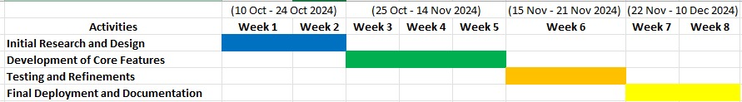
Figure 10: Gantt chart
Source: Self-created

Each group member contributed based totally on their understanding, with effort disbursed throughout the evaluation, design, improvement, and testing phases. An overall of 100 hours were spent completing the task, ensuring all deliverables met the specified high-quality requirements.

The use of those tools and techniques facilitated easy collaboration, clear accountability, and adherence to time limits.

References
Bhati, D., Deogade, M.S. and Kanyal, D. (2023). Improving patient outcomes through effective hospital administration: A comprehensive review. Cureus, [online] 15(10), pp.1–12. Available at: https://pmc.ncbi.nlm.nih.gov/articles/PMC10676194/.
Bordoni, A. (2021). Portfolio Management applied at manufacturing product development pipe: a case of study - Webthesis. Polito.it. [online] Available at: https://webthesis.biblio.polito.it/20104/.
Bressman, E., Long, J.A., Honig, K., Zee, J., McGlaughlin, N., Jointer, C., Asch, D.A., Burke, R.E. and Morgan, A.U. (2022). Evaluation of an Automated Text Message–Based Program to Reduce Use of Acute Health Care Resources After Hospital Discharge. JAMA Network Open, [online] 5(10), p.e2238293. Available at: https://jamanetwork.com/journals/jamanetworkopen/article-abstract/2797716.
De Croon, R., Van Houdt, L., Htun, N.N., Štiglic, G., Vanden Abeele, V. and Verbert, K. (2021). Health Recommender Systems: Systematic Review. Journal of Medical Internet Research, [online] 23(6), p.e18035. Available at: https://www.jmir.org/2021/6/e18035/1000.
Ericsson Duffy, M. (2020). Popularizing implants : Exploring conditions for eliciting user adoption of digital implants through developers, enthusiasts and users. [online] www.diva-portal.org. Available at: https://www.diva-portal.org/smash/record.jsf?pid=diva2:1502817.
Faruque, F. (2024). System interfaces to facilitate follow-up pharmaceutical care in the United States. Mit.edu. [online] Available at: https://dspace.mit.edu/handle/1721.1/155622.
Guesmi, H.A. (2023). A Trust-Driven Optimization of Role-Based Access Control in E-Health Cloud Systems. [online] Journal of Computing & Biomedical Informatics. Available at: https://jcbi.org/index.php/Main/article/view/781.
Haleem, A., Javaid, M., Singh, R.P. and Suman, R. (2021). Telemedicine for healthcare: Capabilities, features, barriers, and applications. Sensors International, [online] 2(2), pp.100–117. Available at: https://pmc.ncbi.nlm.nih.gov/articles/PMC8590973/.
Harris, G. (2020). PROCESS IMPROVEMENT FOR EMERGENCY DEPARTMENT FAST TRACK. thescholarship.ecu.edu. [online] Available at: https://thescholarship.ecu.edu/handle/10342/8659.
Heggelund, M.O. (2023). Information sharing across instances - A case study of implementing an EHR in an emergency room. [online] ntnuopen.ntnu.no. Available at: https://ntnuopen.ntnu.no/ntnu-xmlui/handle/11250/3091566.
Joshua, S.R., Abbas, W., Lee, J.-H. and Kim, S.K. (2023). Trust Components: An Analysis in The Development of Type 2 Diabetic Mellitus Mobile Application. Applied Sciences, [online] 13(3), p.1251. Available at: https://www.mdpi.com/2076-3417/13/3/1251#.
Kavya, N. and Smitha , P. (2022). Deploying and Setting up Ci/Cd Pipeline for Web Development Project on Aws Using Jenkins. International Journal of Advances in Engineering and Management (IJAEM), [online] 4(6), p.2325. Available at: https://ijaem.net/issue_dcp/Deploying%20and%20Setting%20up%20Ci%20Cd%20Pipeline%20for%20Web%20Development%20Project%20on%20Aws%20Using%20Jenkins.pdf.
Larasati, R., De Liddo, A. and Motta, E. (2021). AI Healthcare System Interface: Explanation Design for Non-Expert User Trust. [online] oro.open.ac.uk. Available at: https://oro.open.ac.uk/77436/.
Lee, T.-F., Chang, I-Pin. and Su, G.-J. (2023). Compliance with HIPAA and GDPR in Certificateless-Based Authenticated Key Agreement Using Extended Chaotic Maps. Electronics, [online] 12(5), p.1108. Available at: https://www.mdpi.com/2079-9292/12/5/1108.
Lim, R., Thornton, C., Stanek, J., Ellett, L.K. and Thiessen, M. (2022). Development of a web-based system to report medication-related adverse effects: a design and usability study (Preprint). JMIR Formative Research. [online] Available at: https://formative.jmir.org/2022/10/e37605.
Lin, W. (2024). Ontology, Sustainability and Resilience. [online] Available at: https://harvest.usask.ca/bitstream/10388/14590/1/LIN-DISSERTATION-2023.pdf.
Mrvar, G. (2023). Leveraging Open-Source Data for Software Cost Estimation: A Predictive Modeling Approach. Studenttheses.uu.nl. [online] Available at: https://studenttheses.uu.nl/handle/20.500.12932/44571.
Pedral Sampaio, R., Aguiar Costa, A. and Flores-Colen, I. (2022). A Systematic Review of Artificial Intelligence Applied to Facility Management in the Building Information Modeling Context and Future Research Directions. Buildings, [online] 12(11), p.1939. Available at: https://www.mdpi.com/2075-5309/12/11/1939.
Putri, R.R., Siahaan, D. and Fatichah, C. (2024). COCOMO II-FG-HGWO: A Modified Hunting Gray Wolf Optimization for Improving Constructive Cost Model II Performance. International Journal of Intelligent Engineering and Systems, [online] 17(4), pp.932–943. Available at: https://inass.org/wp-content/uploads/2024/04/2024083170-1.pdf.
Shumilov, M. (2024). Optimization of queries to MySQL and PostgreSQL Databases for High-Load Applications. International Journal of Scientific Engineering and Science, [online] 8(11), p.23. Available at: http://ijses.com/wp-content/uploads/2024/11/91-IJSES-V8N10.pdf.
Srivastava, N., Kumar, U. and Singh, P. (2021). Software and Performance Testing Tools. Journal of Informatics Electrical and Electronics Engineering (JIEEE), [online] 2(1), pp.1–12. Available at: http://jieee.a2zjournals.com/index.php/ieee/article/view/11.
Tinoco, E.N., Lima, R.M., Mesquita, D. and Mariane Cásseres Souza (2023). Using scenarios for the development of personal communication competence in project management. International Journal of Project Organisation and Management, [online] 15(3), pp.307–331. Available at: https://www.inderscienceonline.com/doi/abs/10.1504/IJPOM.2023.132711.
Varnosfaderani, S.M. and Forouzanfar, M. (2024). The Role of AI in Hospitals and Clinics: Transforming Healthcare in the 21st Century. Bioengineering, [online] 11(4), p.337. Available at: https://www.mdpi.com/2306-5354/11/4/337.
Wendroth, J. and Jaeger, B. (2022). A Brief Overview on HTTP. [online] Available at: https://www.net.in.tum.de/fileadmin/TUM/NET/NET-2022-11-1/NET-2022-11-1_11.pdf.
Yevseiev, S., Havrylova, A., Milevskyi, S., Sinitsyn, I., Chalapko, V., Dukin, H., Hrebeniuk, V., Diedov, M., Bekirova, L., Shpak, O. and Шпак, Олександр Іванович (2023). Development of an improved SSL/TLS protocol using post-quantum algorithms. Uzhnu.edu.ua. [online] Available at: https://dspace.uzhnu.edu.ua/jspui/handle/lib/57871.
Yusof, Y.B., Ping, T.H. and Isa, F.B.M. (2023). Strengthening Smart Grids Through Security Measures: A Focus on Real-Time Monitoring, Redundancy, and Cross-Sector Collaboration. International Journal of Intelligent Automation and Computing, [online] 6(3), pp.14–36. Available at: https://research.tensorgate.org/index.php/IJIAC/article/view/49.

Appendices

Appendix A: Contributions Table
Table 1: Contributions Table
Task | Member A | Member B | Member C | Member D | Hours
Requirements Analysis | ✓ | ✓ |  |  | 15
Software Architecture Design | ✓ |  | ✓ |  | 20
Core Feature Development |  | ✓ | ✓ | ✓ | 30
Testing and Bug Fixing |  | ✓ |  | ✓ | 25
Documentation and Final Report | ✓ |  |  | ✓ | 10

Appendix B: Agreement of Participation
We, the undersigned members of the project group, confirm that we have contributed to this project as outlined in the Contributions Table. We agree that the mark for this project will be shared equally unless otherwise indicated by the module tutor.
Table 2: Student Details
Student ID | Name | Signature
U2794451 | Het Ramanbhai PATEL | HET
U2799710 | Soham Nareshbhai PATEL | SOHAM
U2740118 | Anmol PUNDIR | ANMOL
U2780253 | Shisir REGMI | SHISIR

Appendix C: Glossary
Table 3: Glossary
Term | Definition
HIPAA | Health Insurance Portability and Accountability Act, a US regulation for secure healthcare data.
GDPR | General Data Protection Regulation, an EU law for data privacy and security.
EHR | Electronic Health Records, a system for maintaining patient medical records digitally.
RBAC | Role-Based Access Control, a system of restricting access based on user roles.
KLOC | Thousand Lines of Code, a metric for measuring software size.
2FA | Two-Factor Authentication, a security measure requiring two forms of verification.

Appendix D: Analysis and Design Models
1. Class Diagram: A specific class diagram showcasing relationships among middle entities together with Patients, Feedback, Recommendations, and Hospital Management Systems (HMS).
2. Entity-Relationship Diagram (ERD): A diagram showing database relationships, inclusive of entities for Patients, Feedback Records, Appointments, and User Roles.
3. State-Transition Diagram: A diagram outlining the device states (e.g., Feedback Submission, Data Processing).

Appendix E: To Do List
Table 4: To Do List
Task ID | Task Description | Assigned To | Status
T1 | Complete testing of feedback module. | Member B | In Progress
T2 | Finalize integration with hospital APIs. | Member C | In Progress
T3 | Proofread and finalize documentation. | Member D | Pending
T4 | Add additional glossary terms. | Member A | Completed

Appendix F: Source Code
https://github.com/Karthikg1908/Hospital-Management-System

10.7 Appendix G: System Screenshots
Admin Side Panel: -

1) Website look
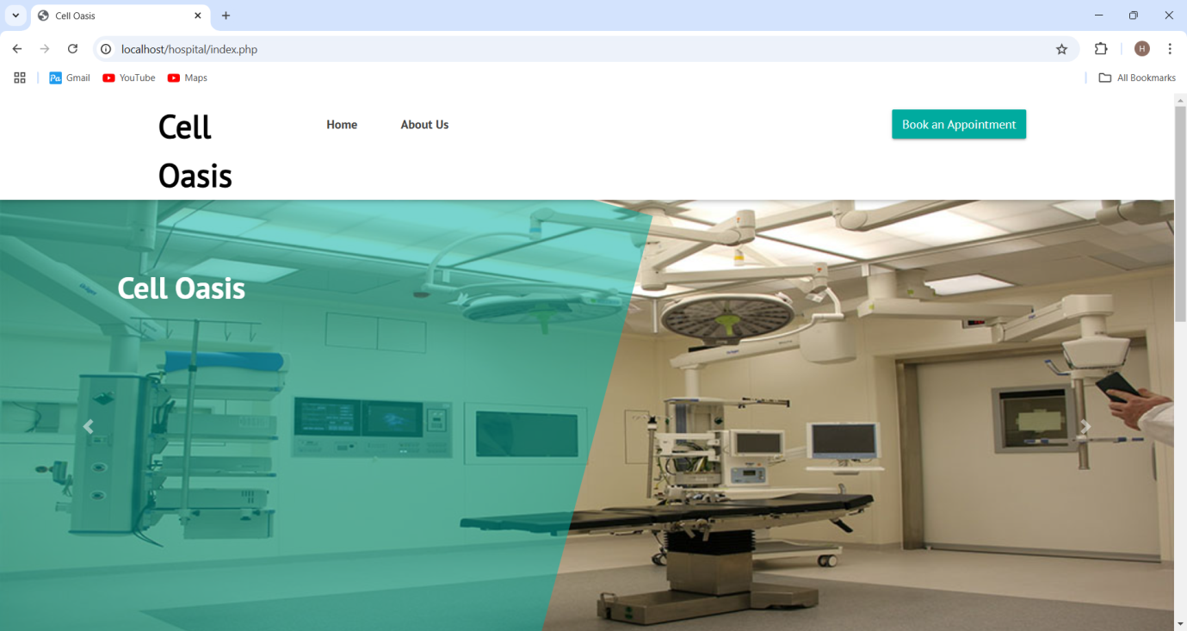
2) Login button look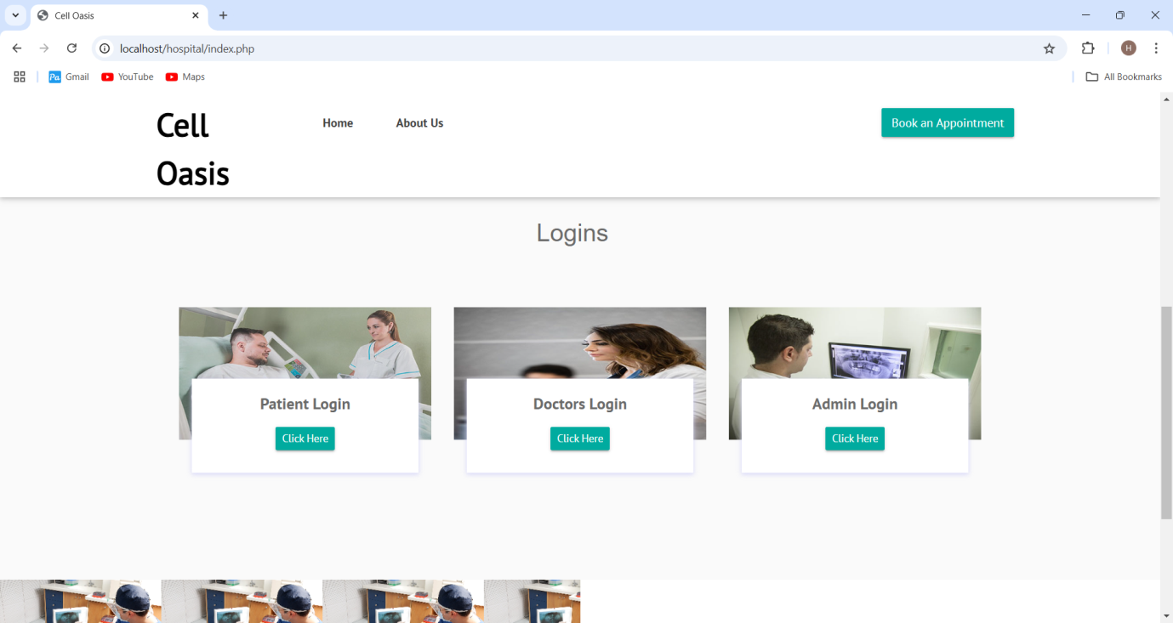

3) Bottom View
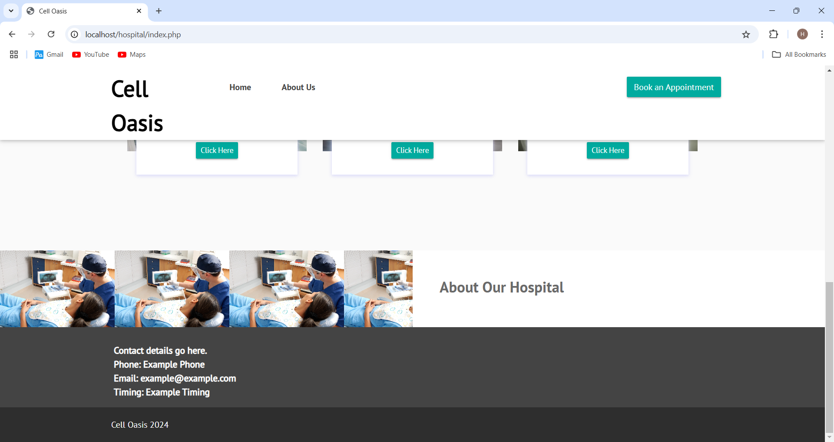

4) admin side login Page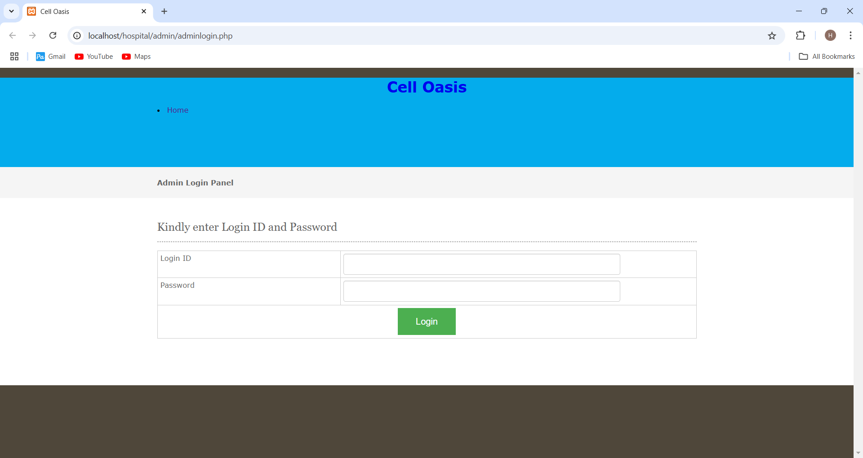

5) after admin login Screenshot 1
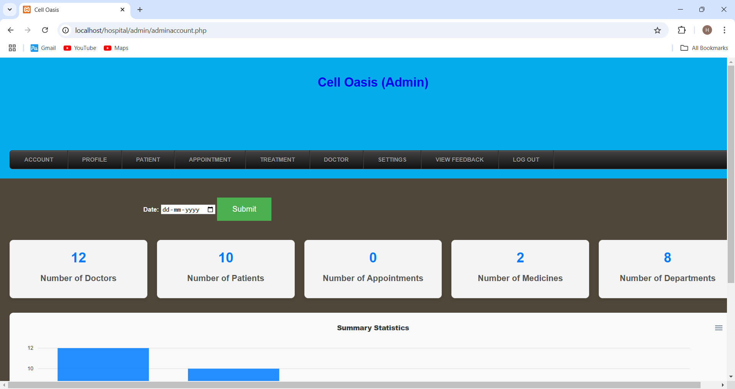

6) after login screenshot 2
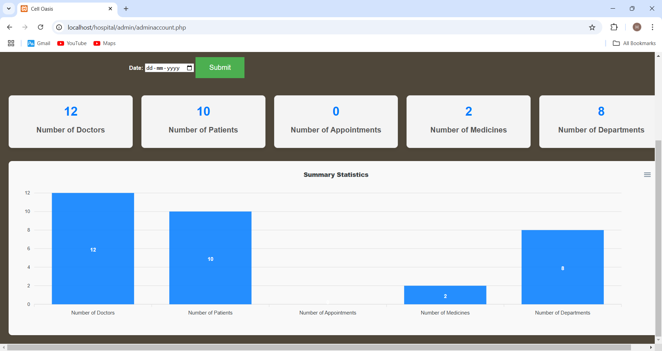

7) admin can add patient
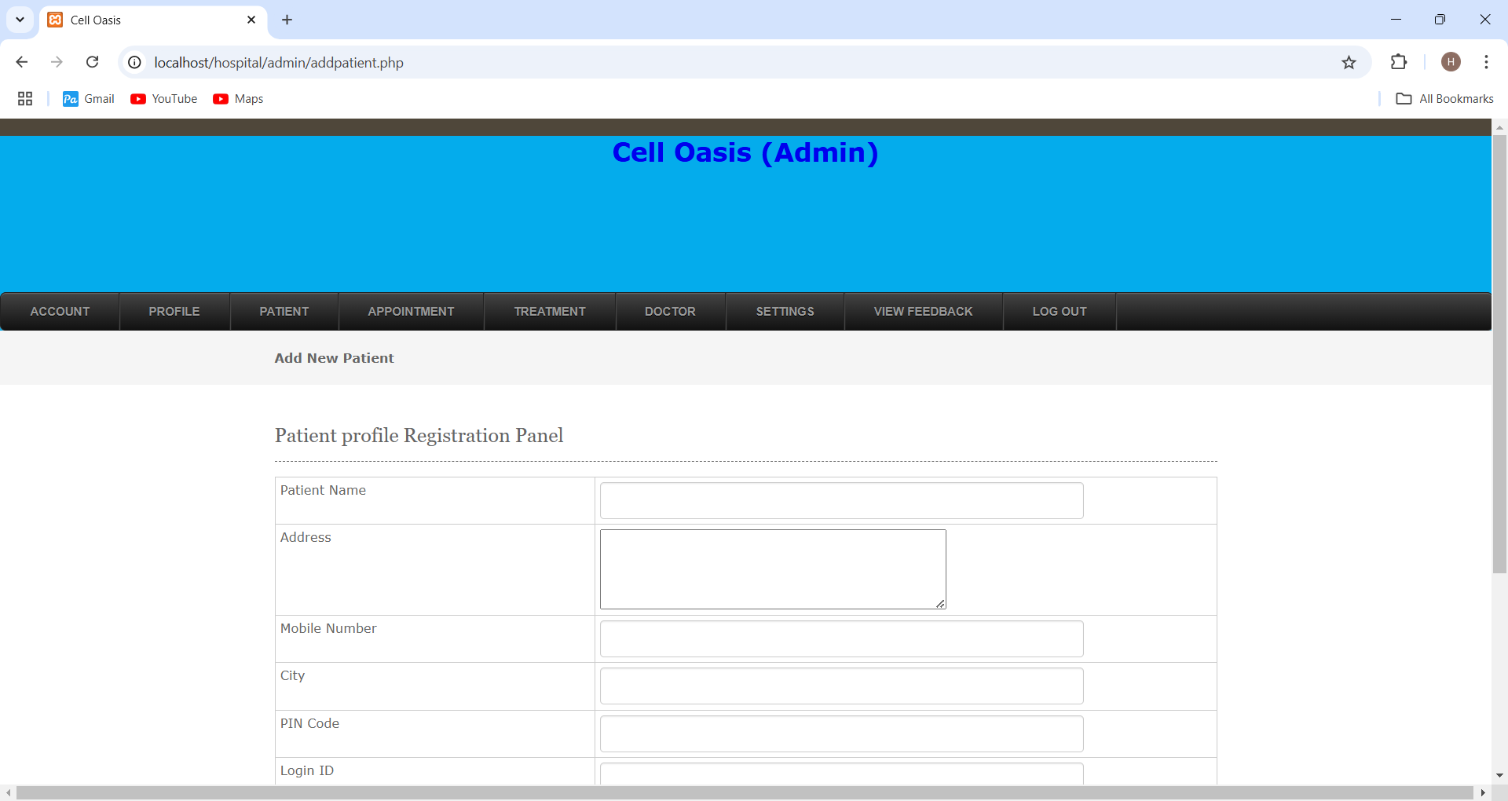

8) patient record
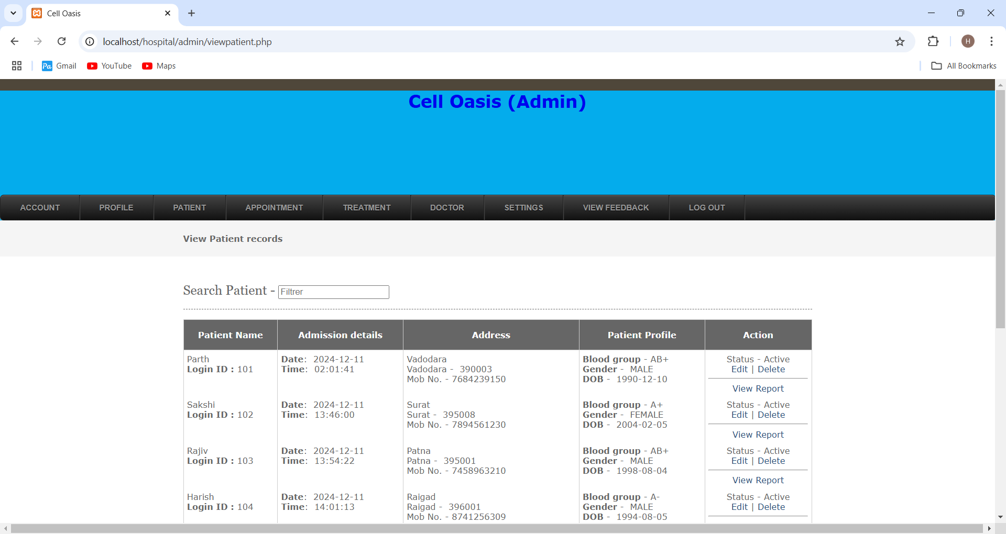

9) Appointment record pending
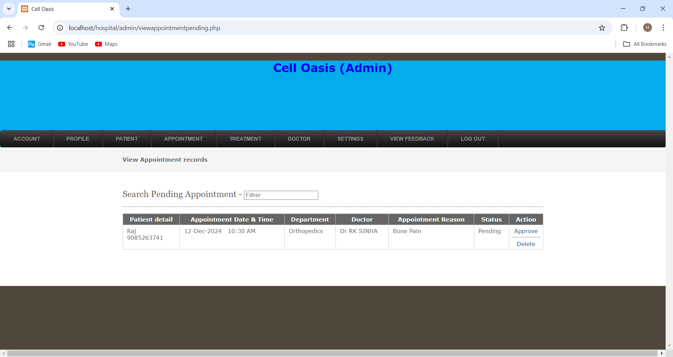

10) Appointment record approved
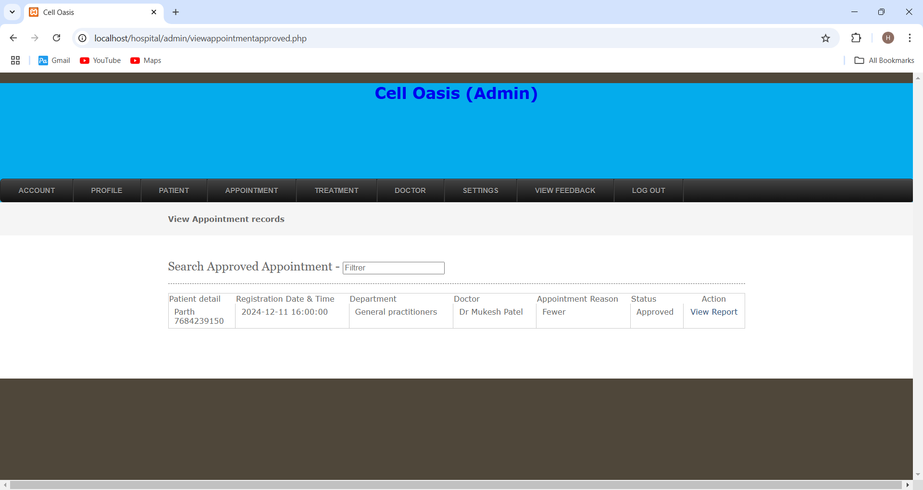

11) Doctor Details
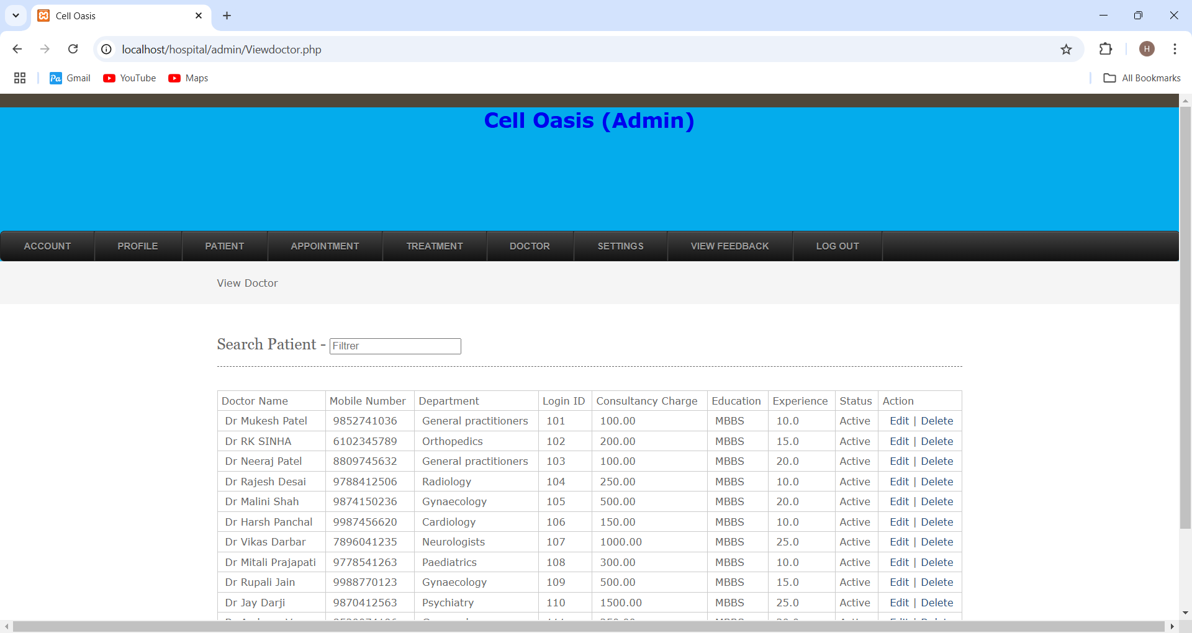

12) Hospital Department
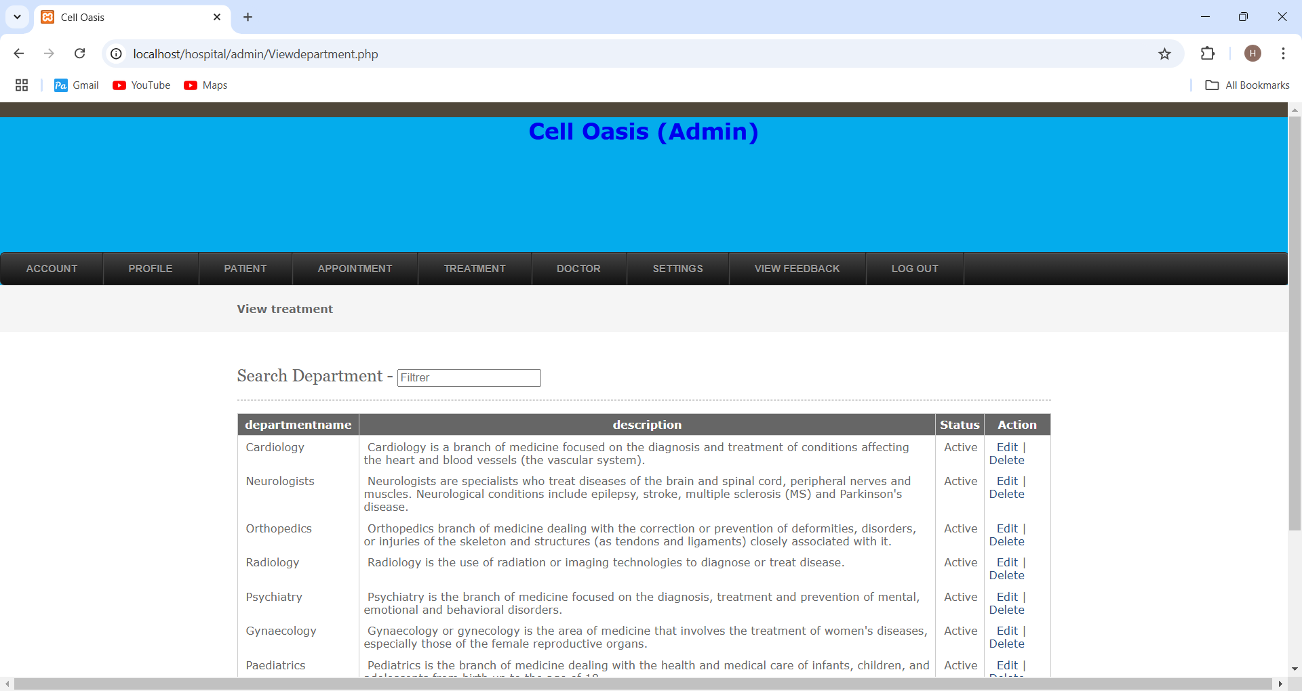

13) Treatment types
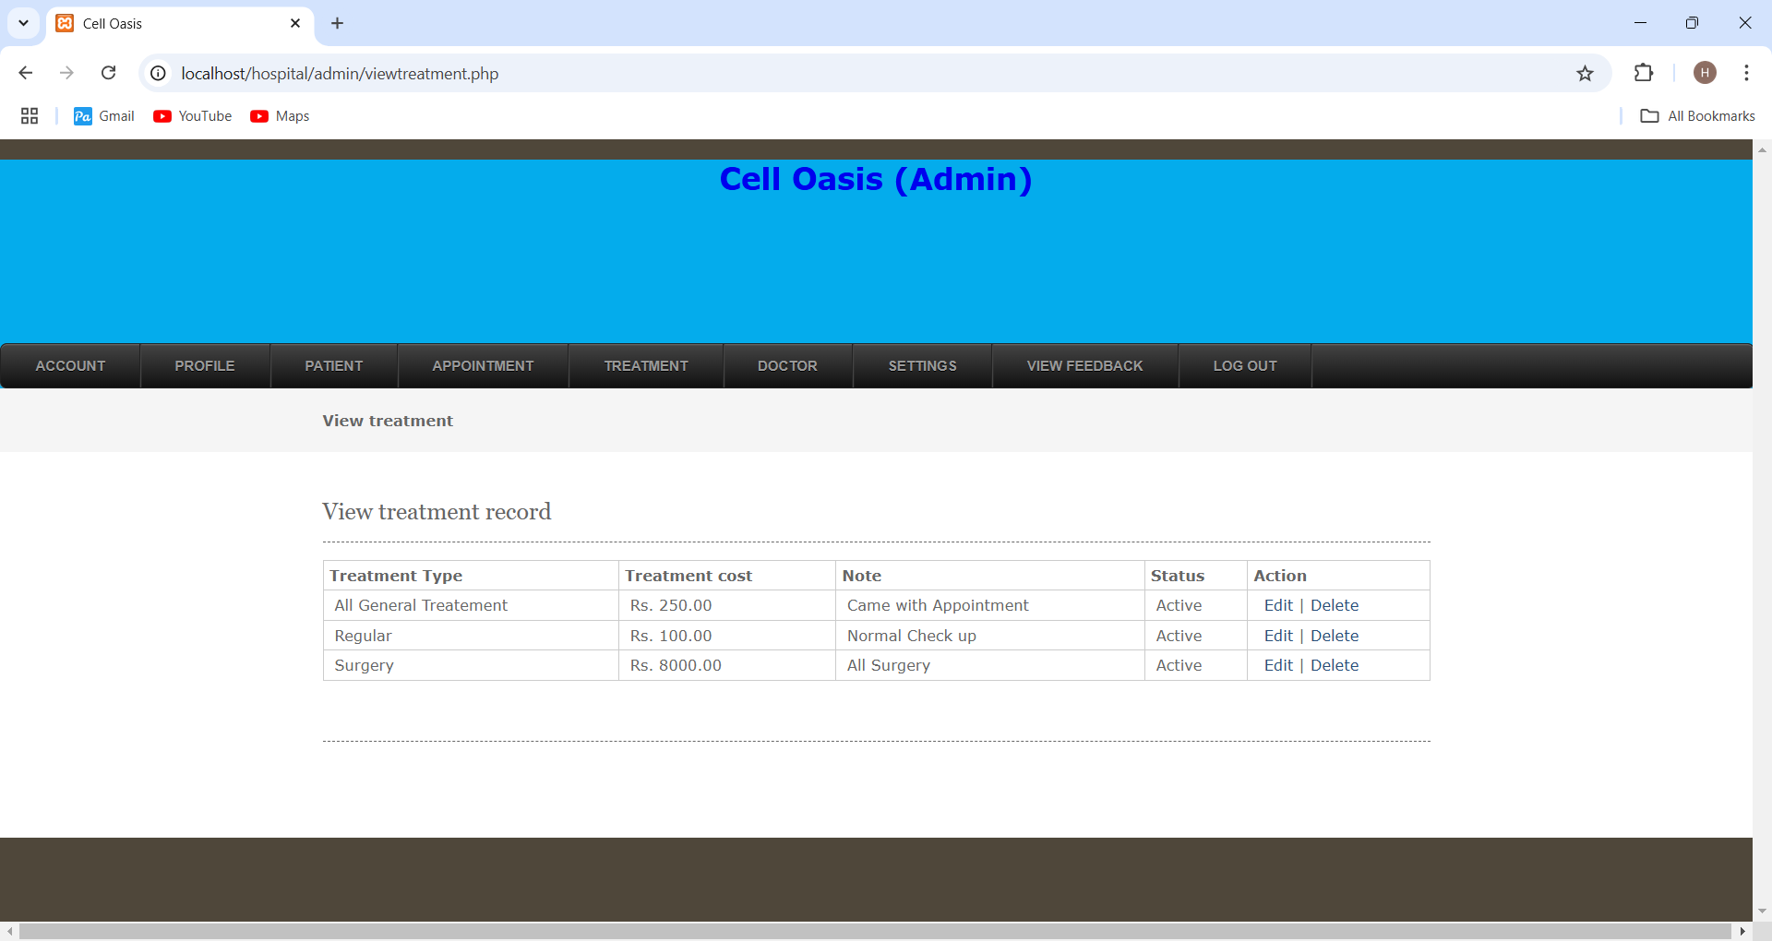

14) Treatment Record
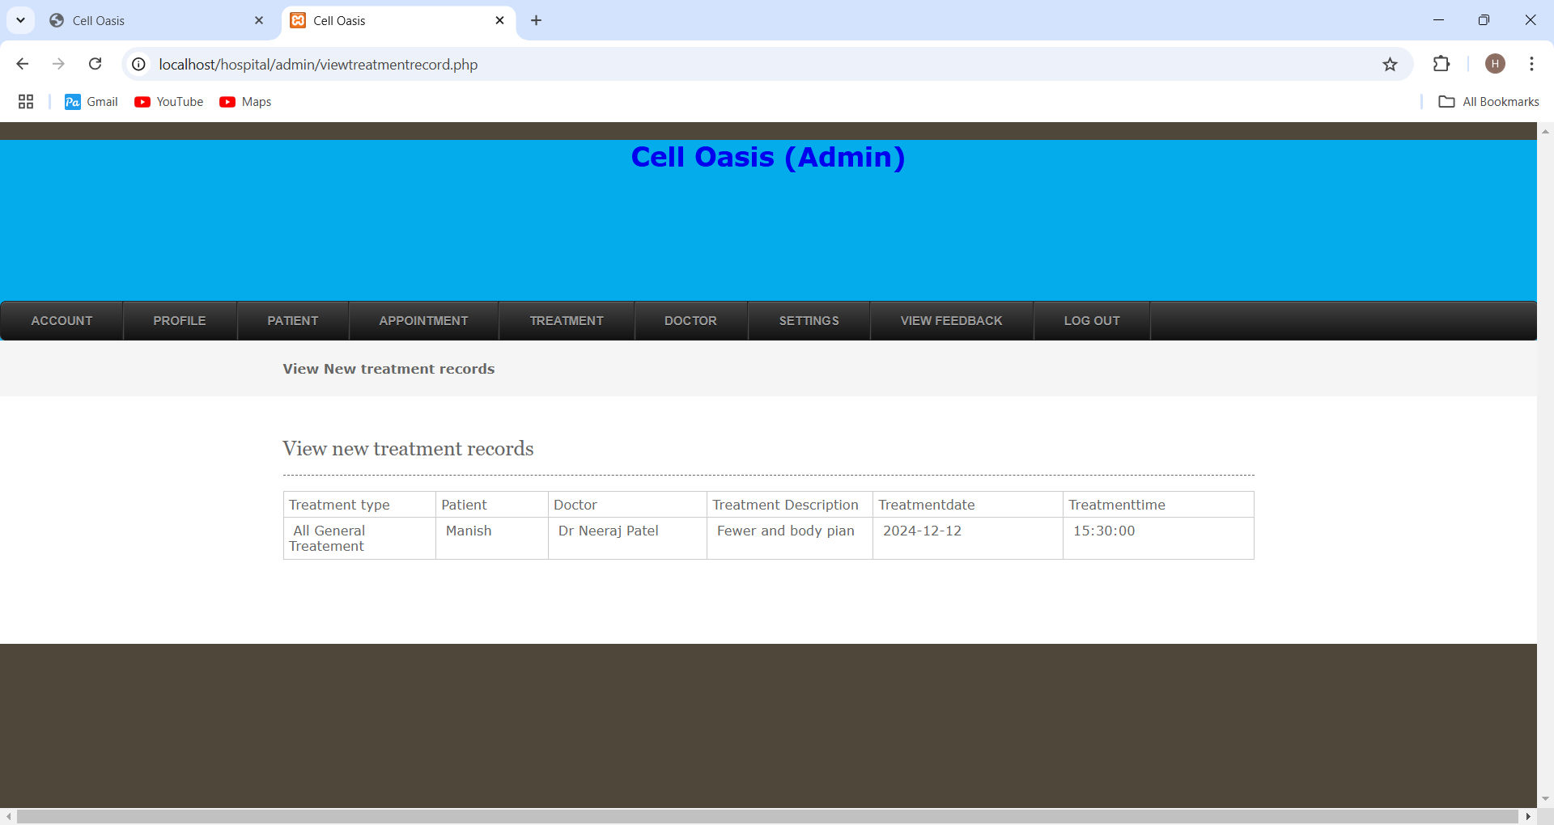

15) Medicine Details
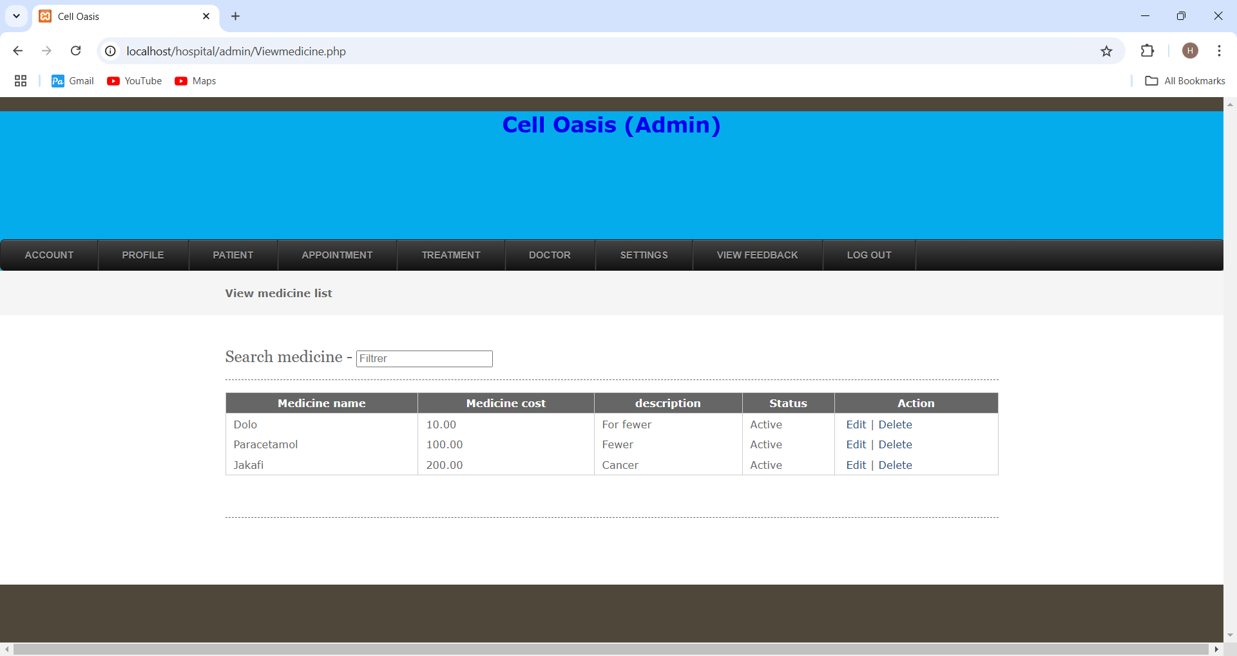

16) Feedback side
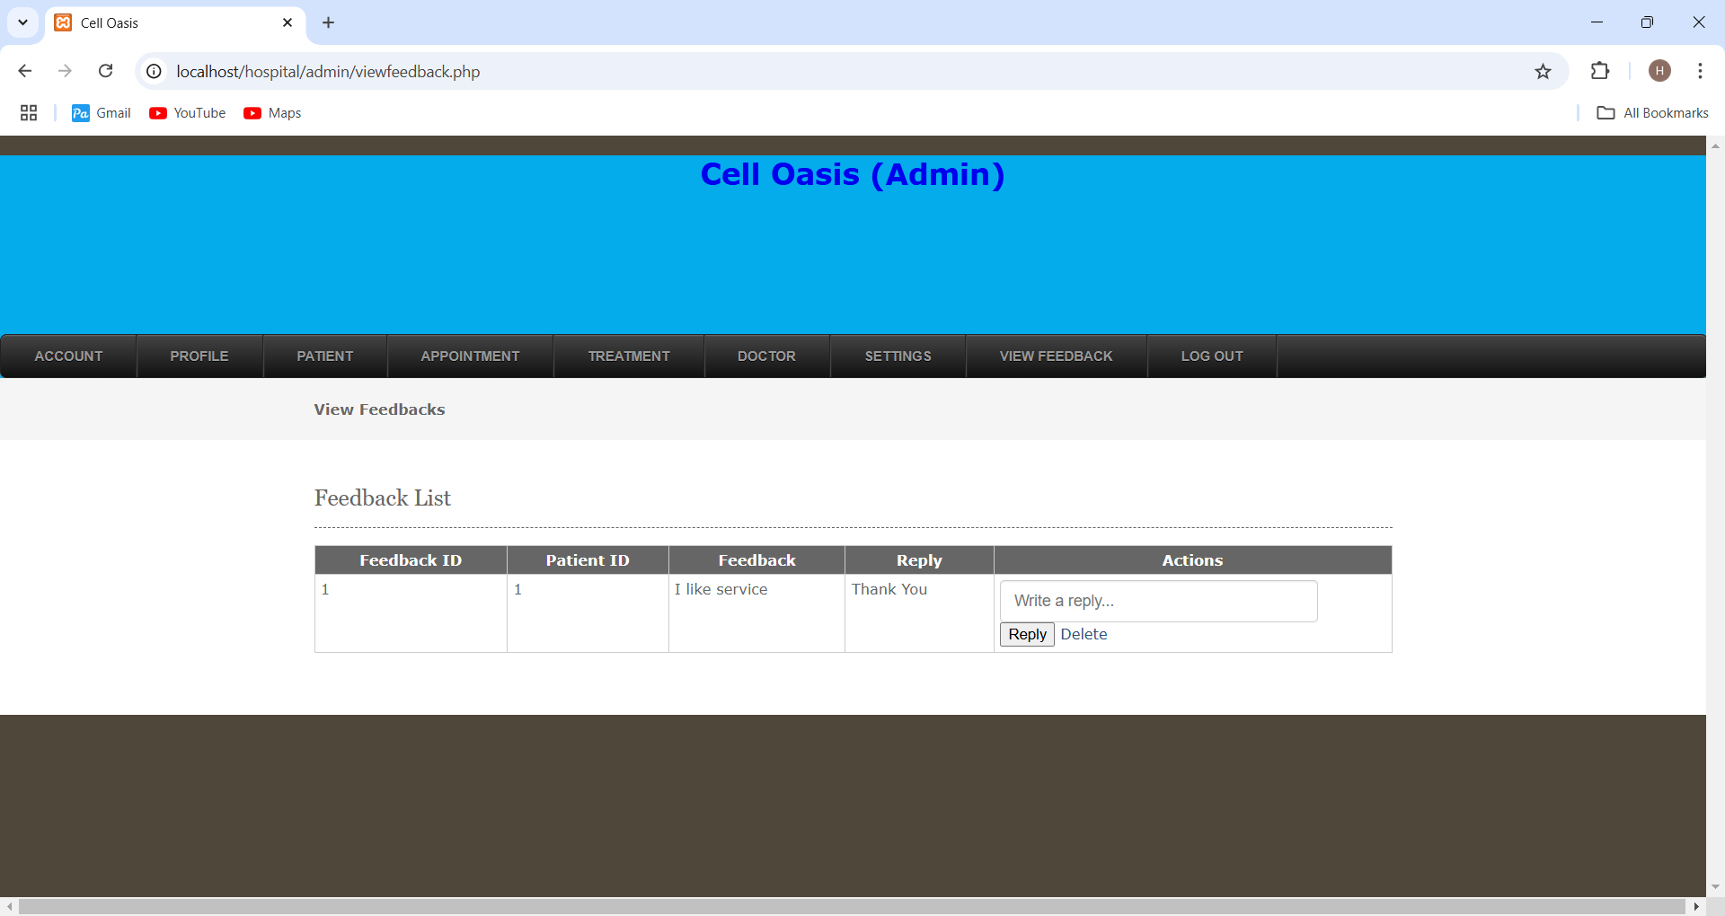

Doctor Side Panel: -

1) Login Page of Doctor
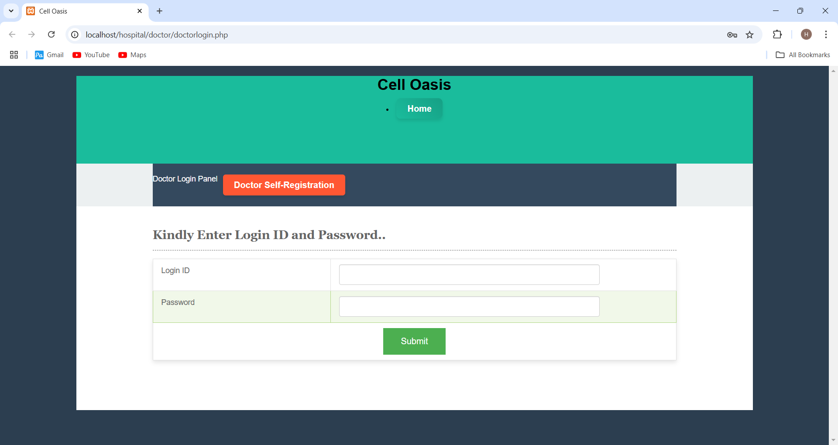

2) Doctor Can register them Selves
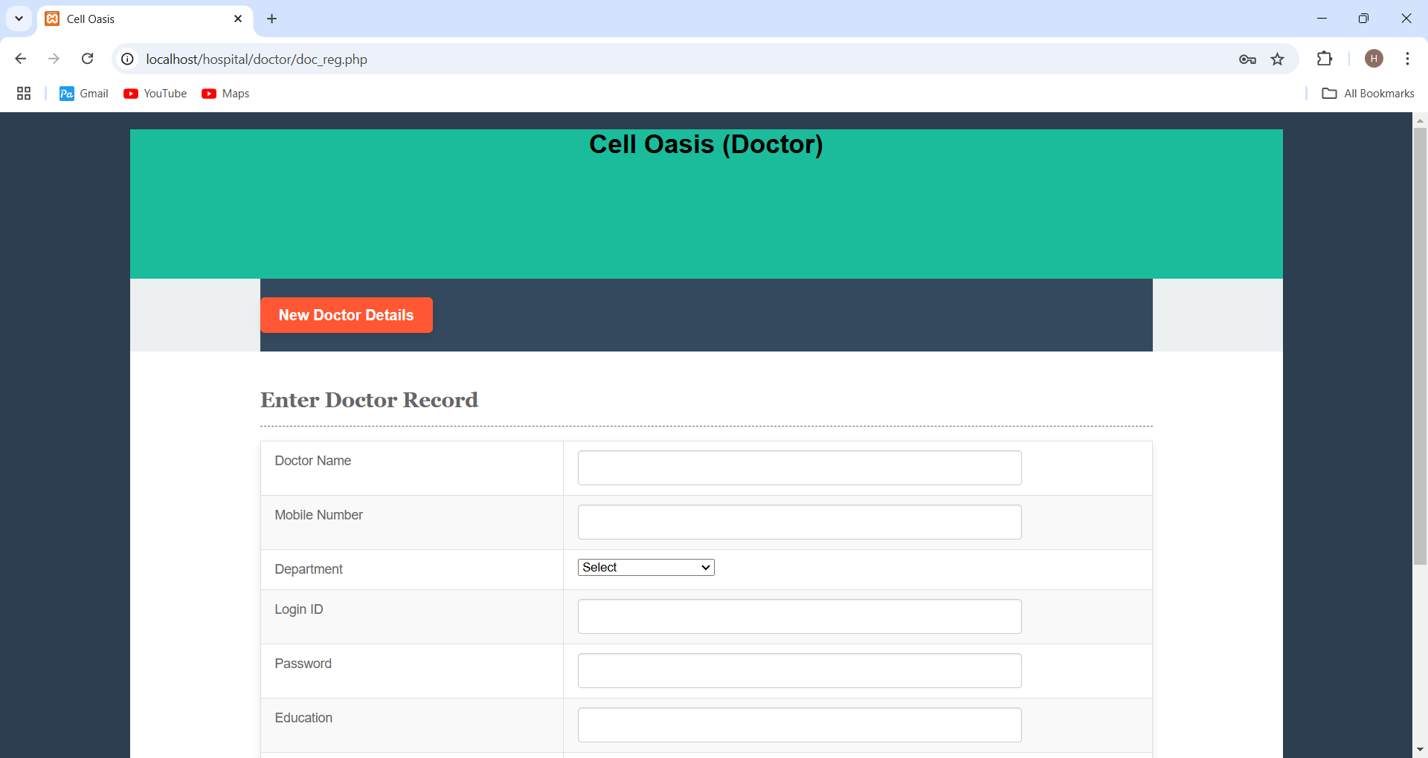

3) After Doctor Login
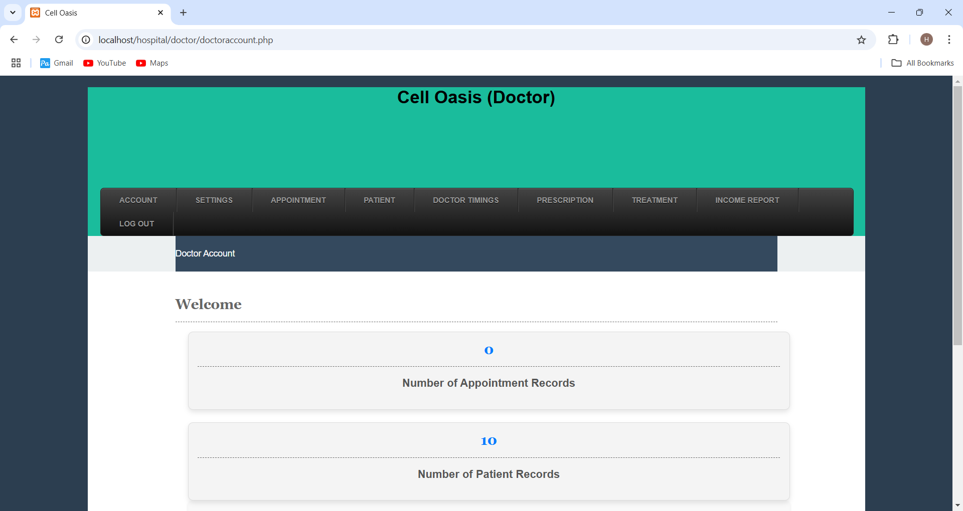

4) Appointment pending section
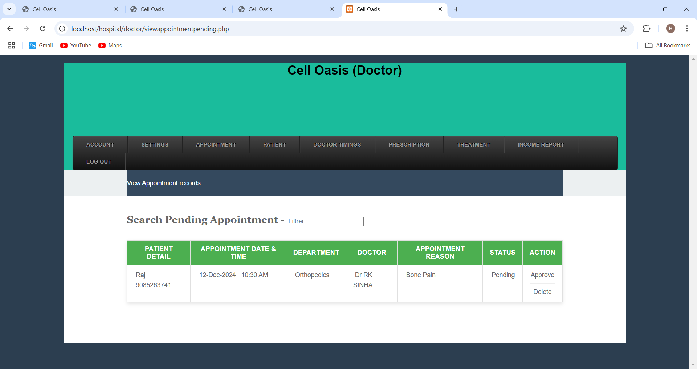

5) Appointment After Approved
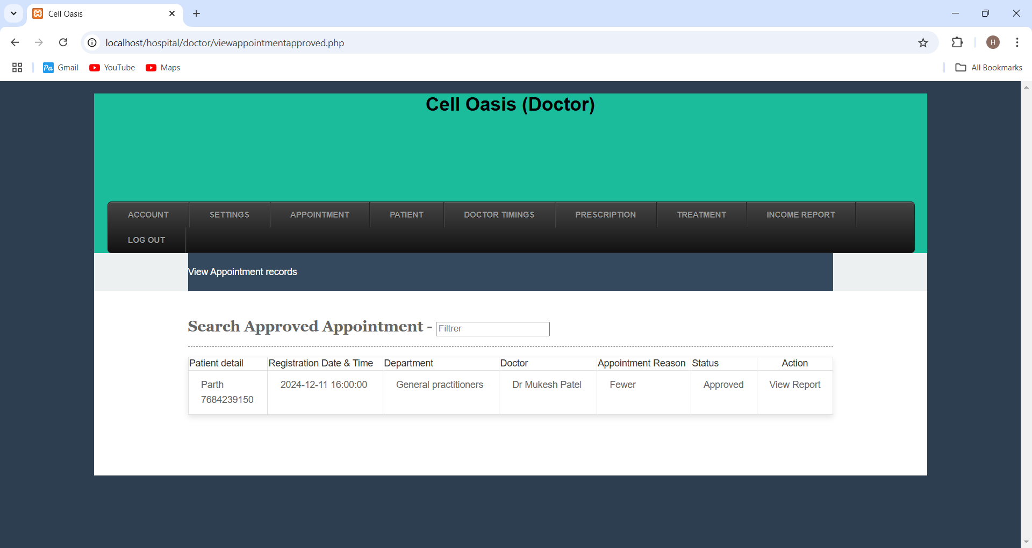

6) Doctor side patients’ details
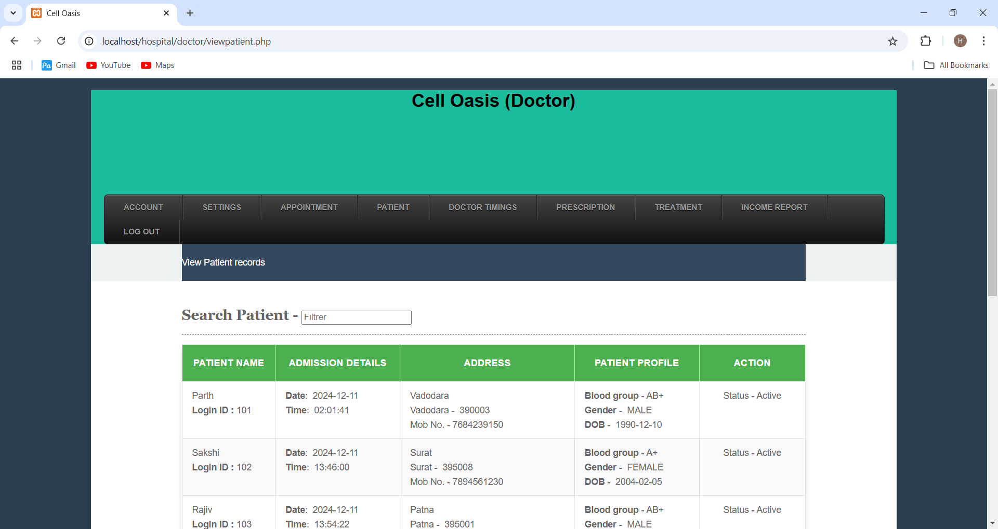

7) Doctor Timing
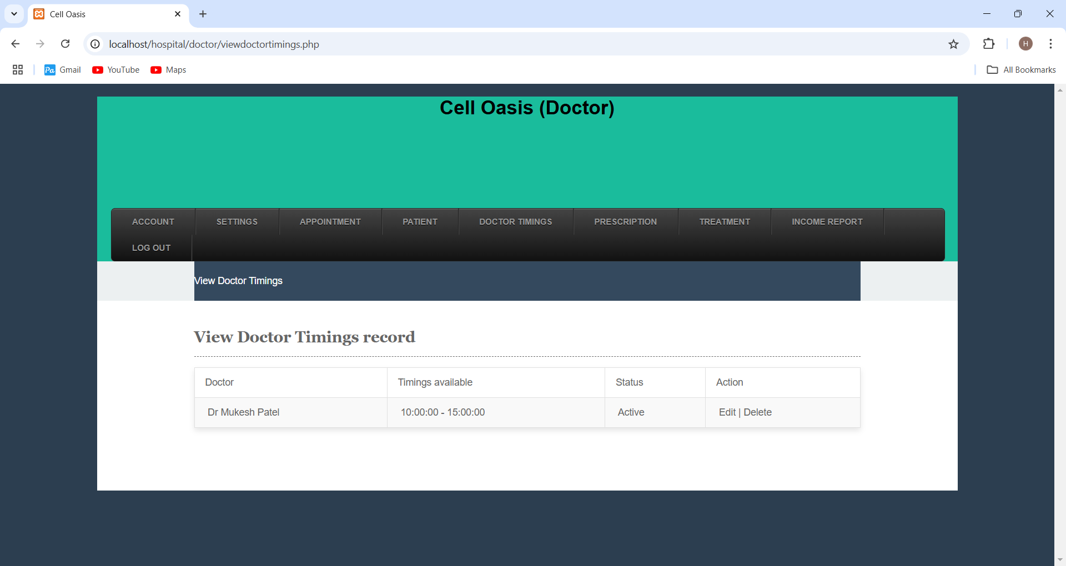

8) Prescription page
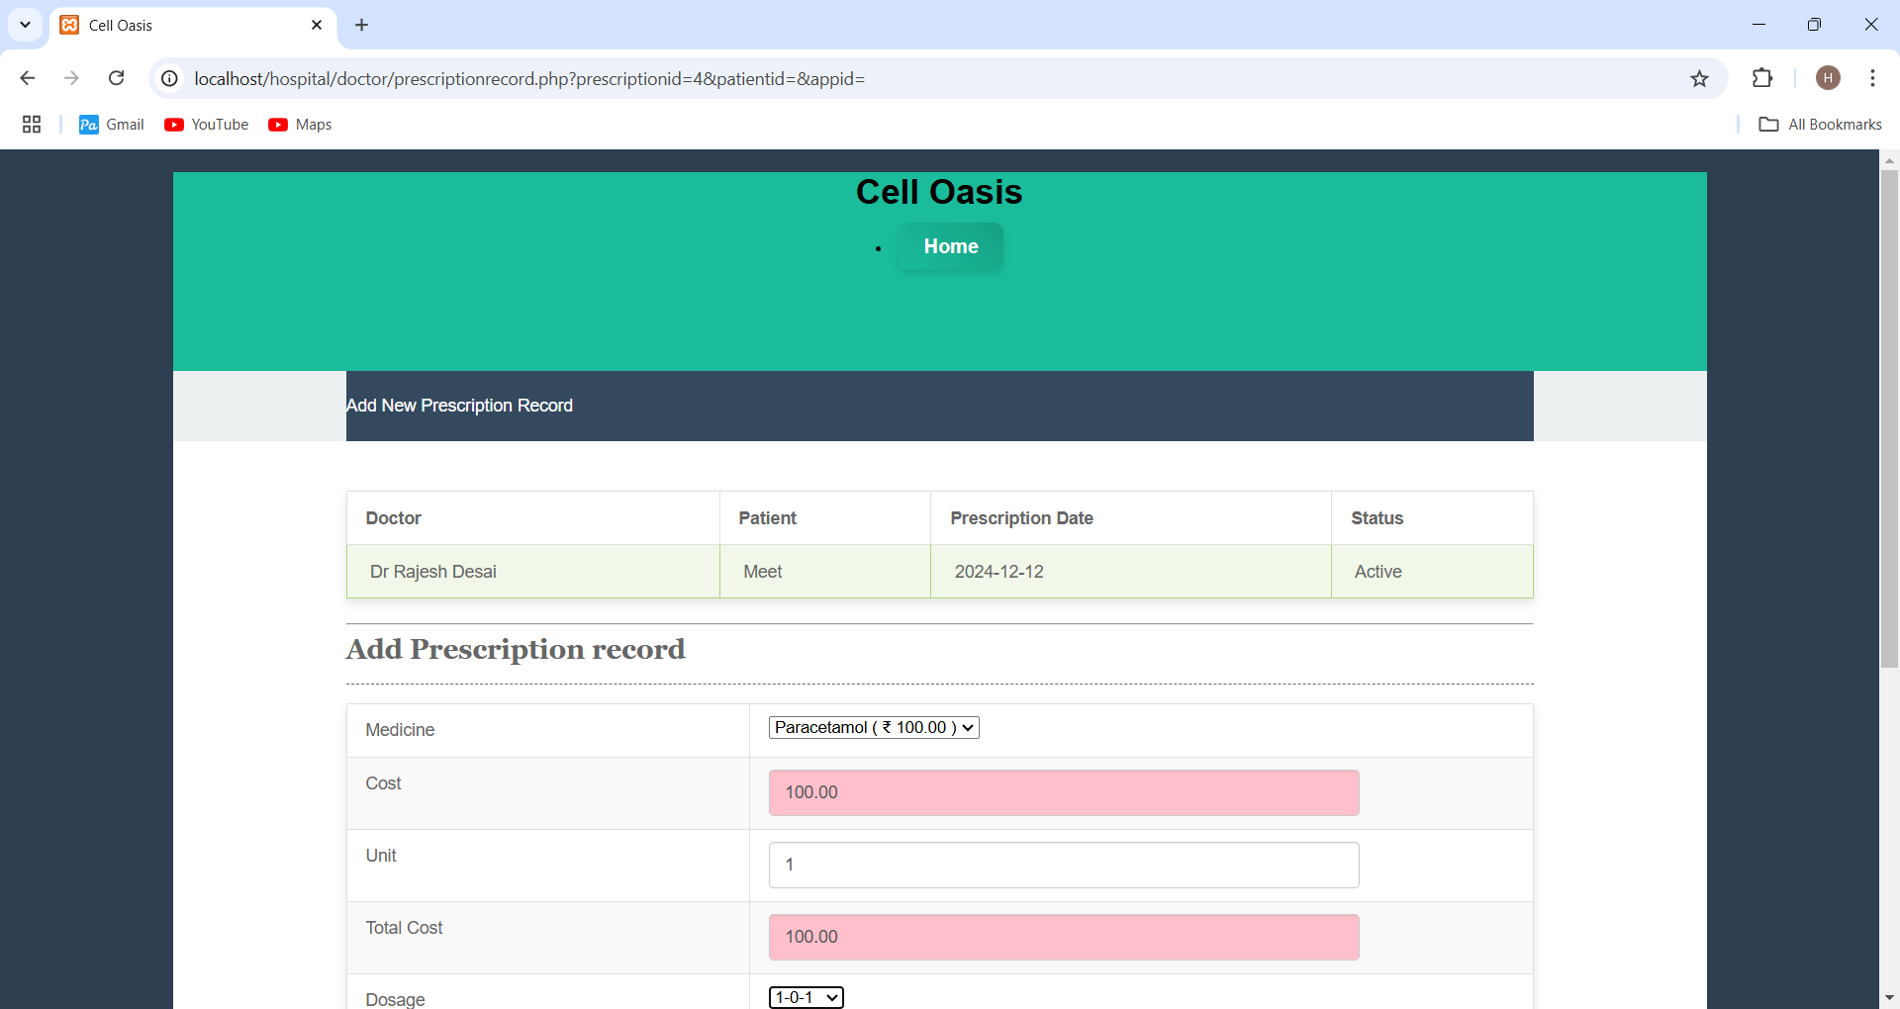

9) Doctor can view Patient Appointment and Medical


10) Doctors can manage their Timing and view
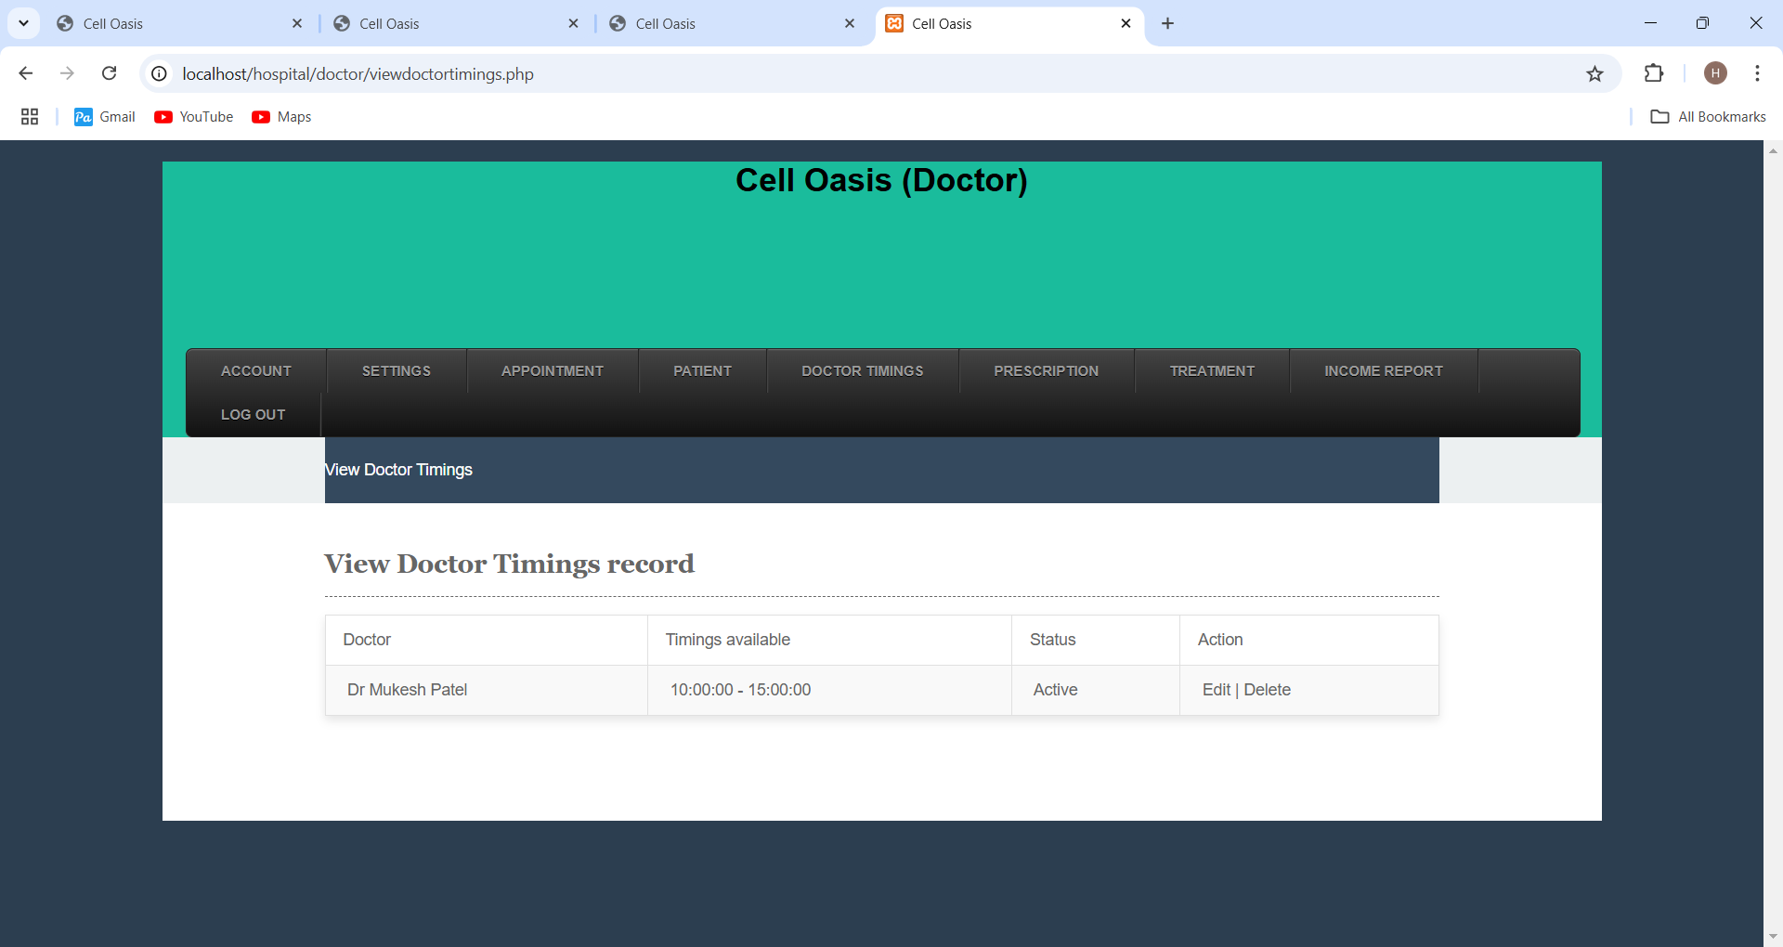

Patient side Panel: -

1) Patient Login Page
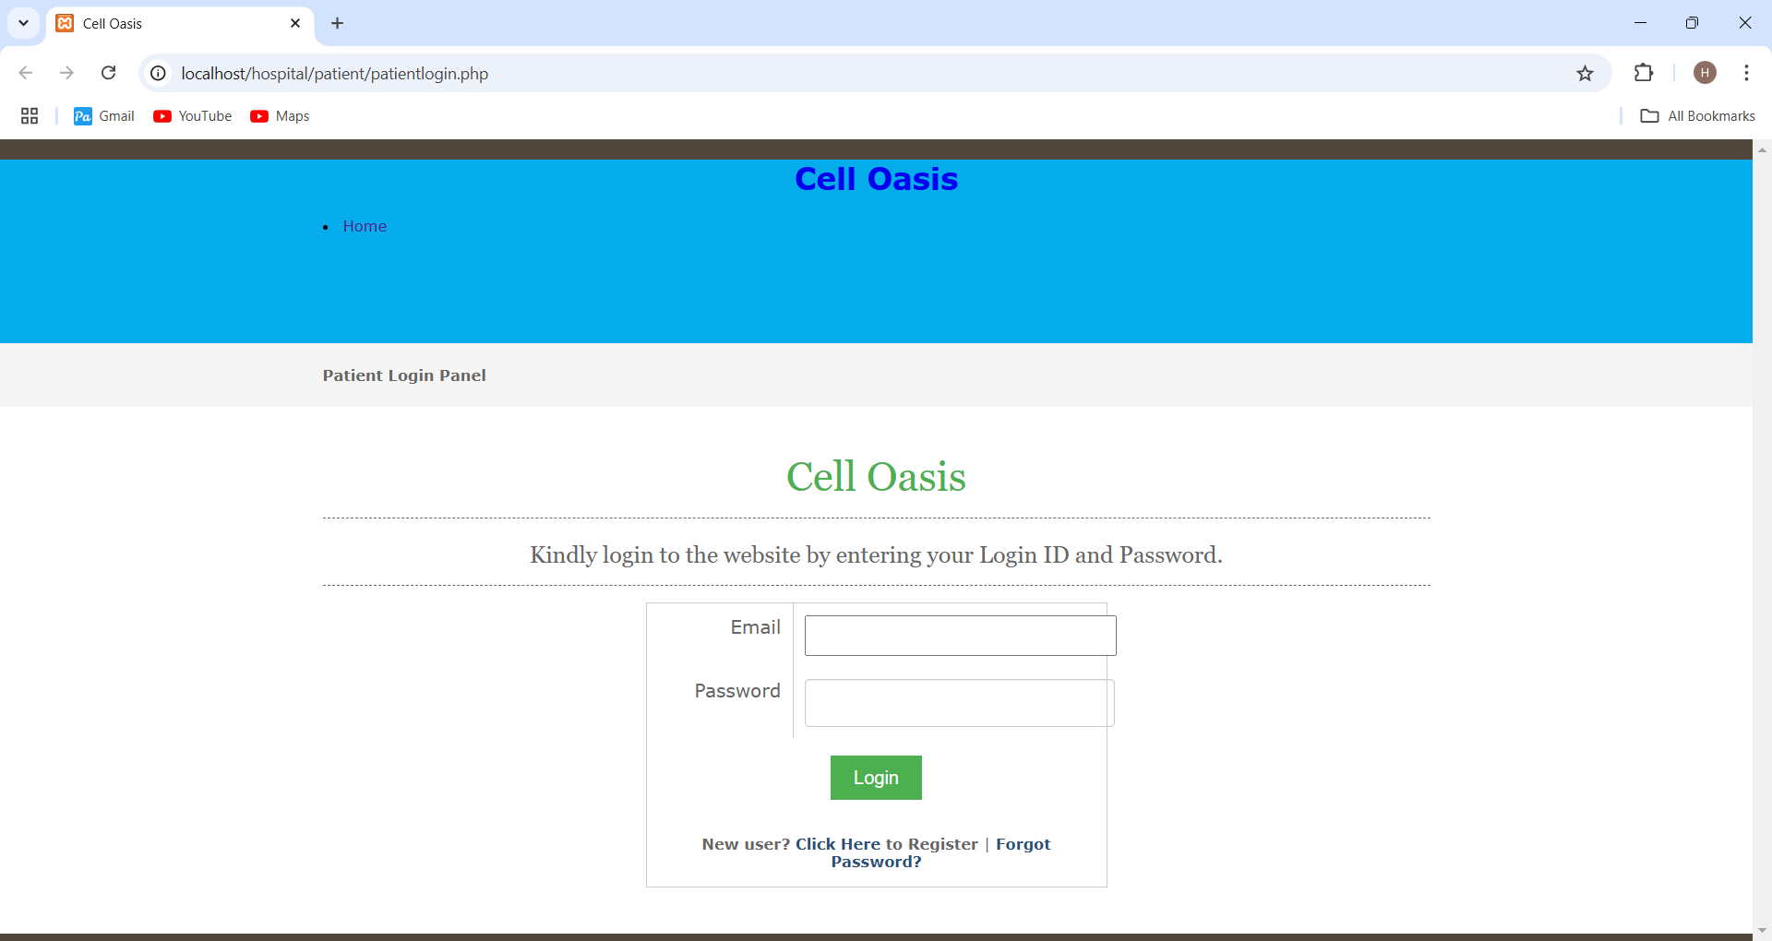

2) Patient can register themselves
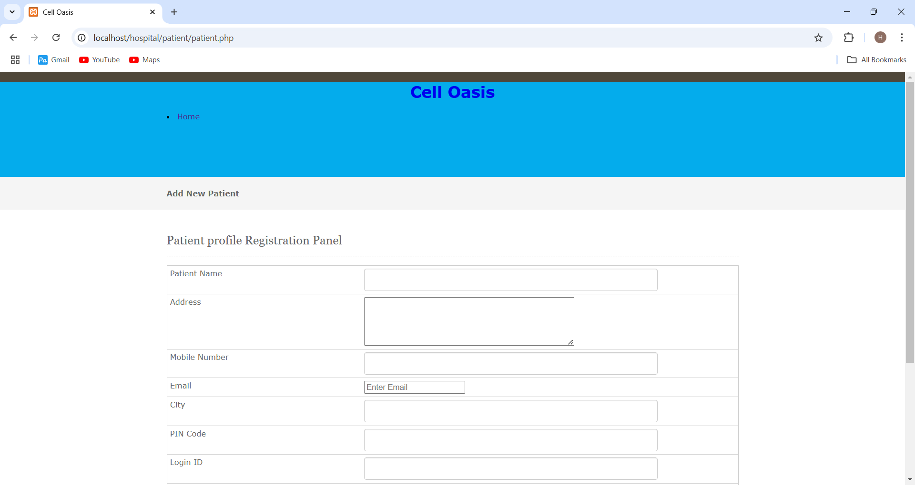

3) OTP verification for patient side


4) After Verify patient Email
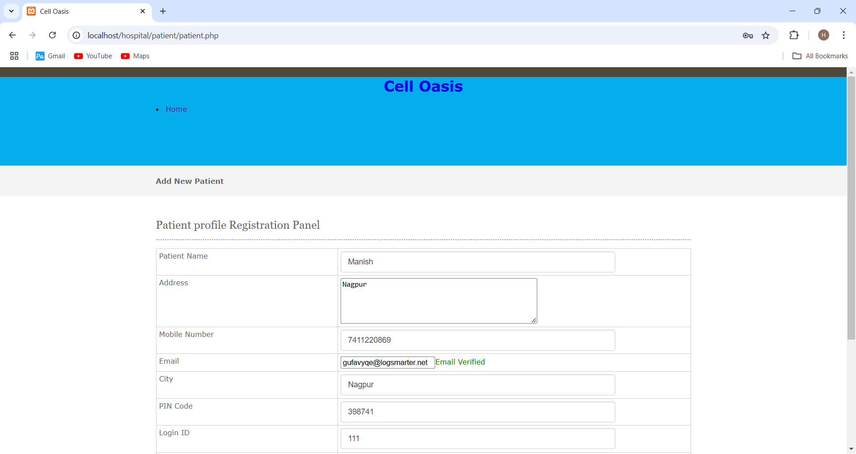

5) After patient login
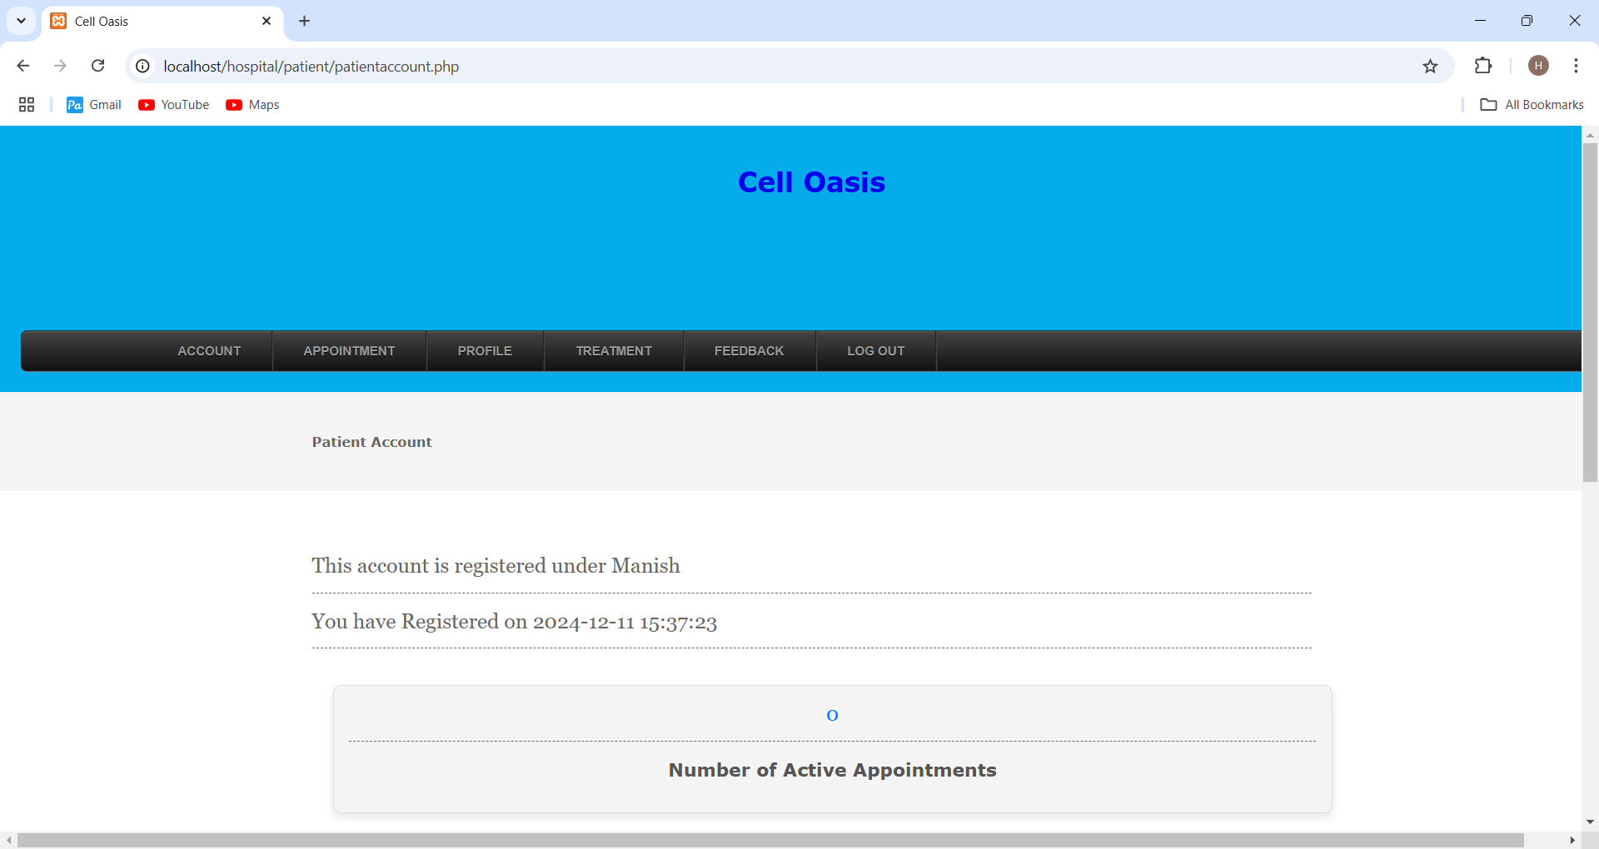

6) Patients can book appointment
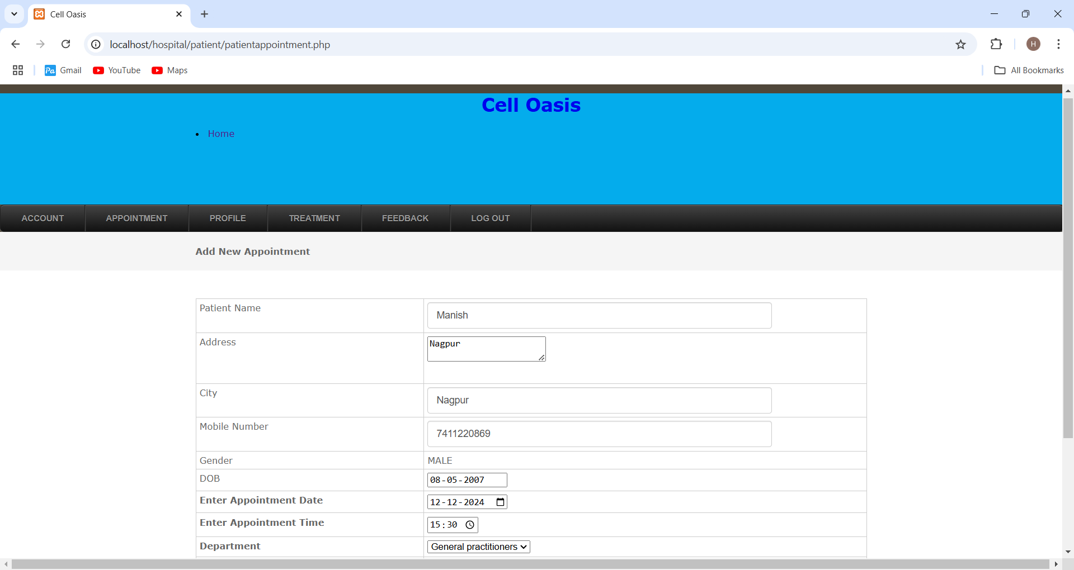

7) Patient can view their appointments
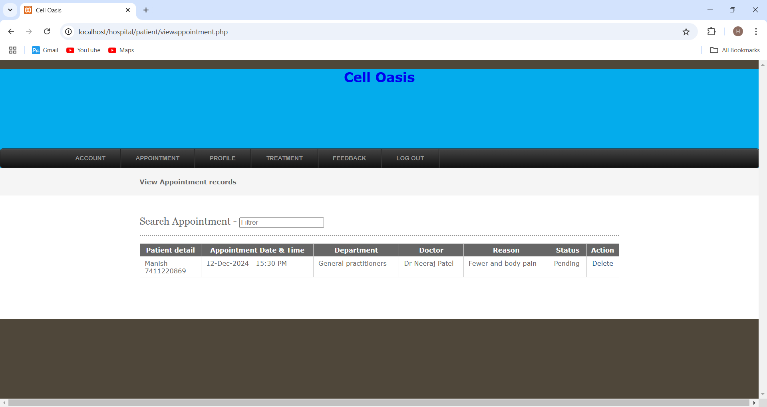

8) Treatments Record
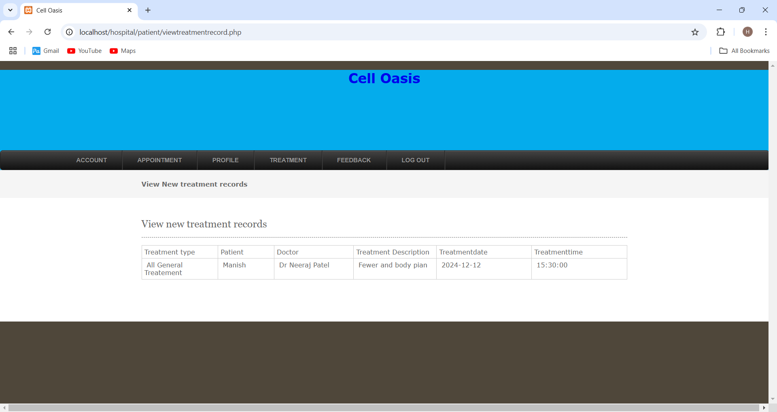

9) Patient can give feedback to admin
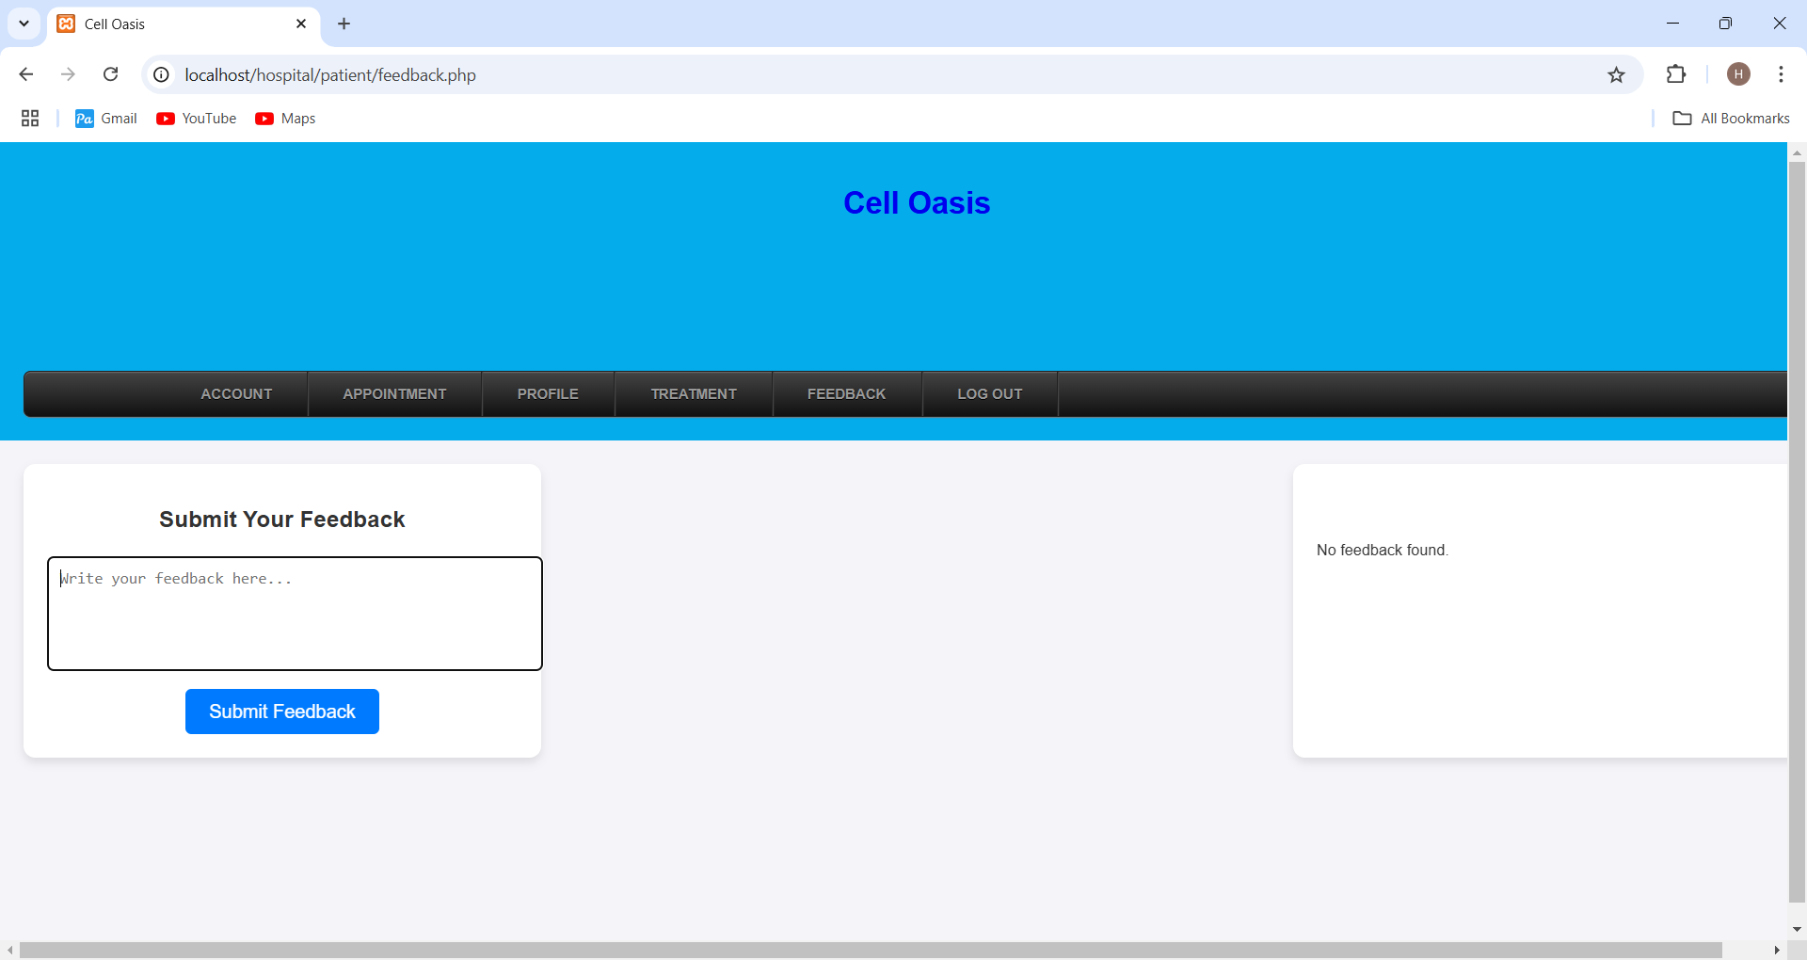

10) After Getting reply from admin
